

ESA Support to Science Element

**-SMOS+STORM Evolution –**

**Validation Reports**

ESA Contract Change Notice No. 4000105171/12/I-BG

**Deliverable**

|  |  |
| --- | --- |
| Customer | ESA/ESRIN |
| ESA Contract Change Notice No | 4000105171/12/I-BG |
| Document Reference | SMOSpluSTORMEvolution_MPR68_v1.1 |
| Version/Rev | 1.1 |
| Date of Issue | 19 Jan 2015 |

|  |  |  |  |  |
| --- | --- | --- | --- | --- |
|  | Function | Name | Signature | Date |
| Prepared by/Lead Author | Project Manager  & Consortium | Nicolas Reul  IFREMER,  Met Office, Ocean Datalab |  | 5 of Dec 2014 |
| Accepted by | ESA technical Officer | Craig Donlon |  |  |

1.0 Purpose of the document 4

2.0 Overview of the Progresses for Oct -Dec 2014: KO+6, KO+7 & KO+8 Erreur ! Signet non défini.

3.0 Detail Progresses for Oct -Dec 2014: KO+6, KO+7 & KO+8 Erreur ! Signet non défini.

4.0 Project Schedule status Erreur ! Signet non défini.

5.0 Problems/issues Erreur ! Signet non défini.

6.0 International Scientific Cooperations Erreur ! Signet non défini.

7.0 User impact and feed back Erreur ! Signet non défini.

8.0 Project outreach/promotion Erreur ! Signet non défini.

9.0 Planned Activities in next month Erreur ! Signet non défini.

10.0 Next project meeting Erreur ! Signet non défini.

# Purpose of the document

This document present a validation report of SMOS STORM products

# Validation of the First Version of the SMOS-HWS database using SFMR flight data

## North Atlantic Hurricane Season 2010

### Tropical Storm Colin

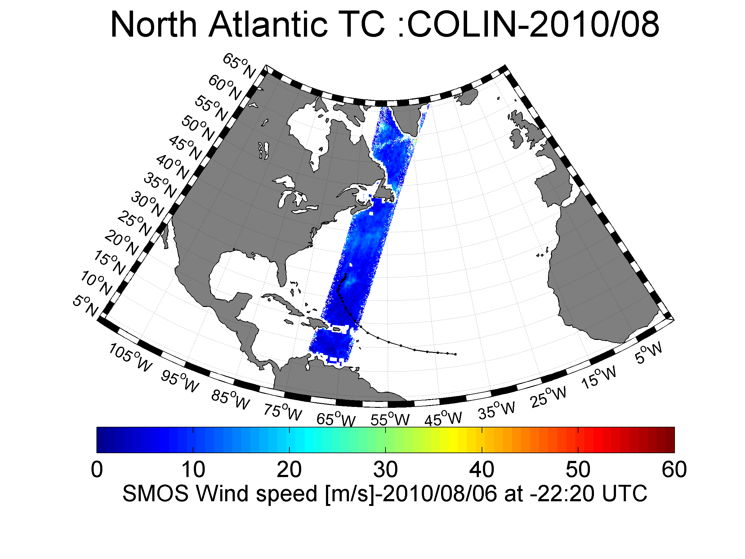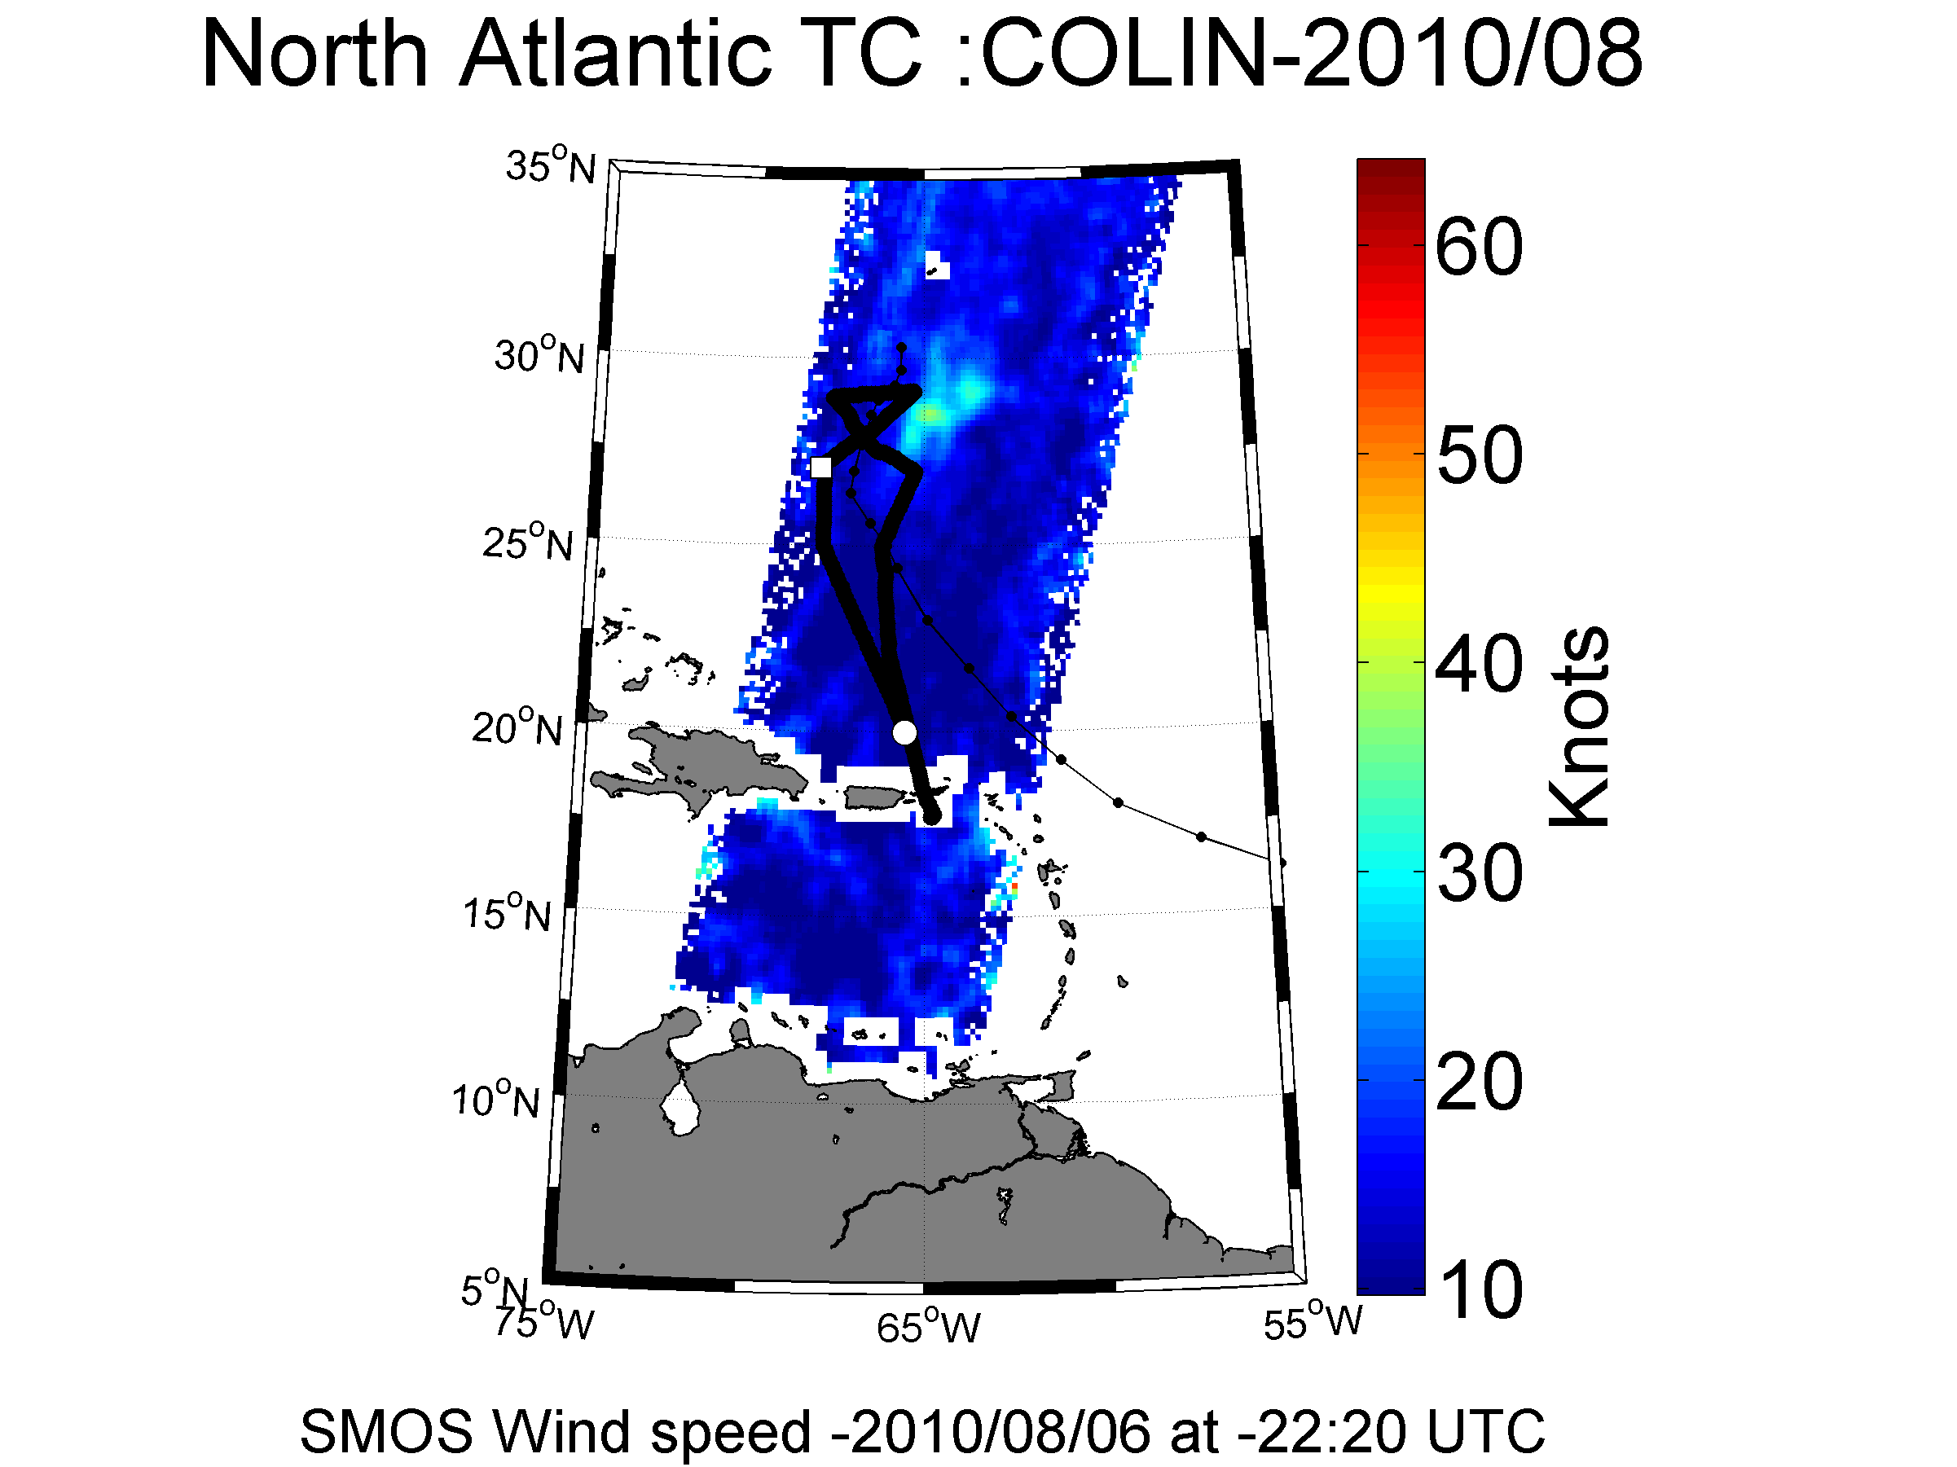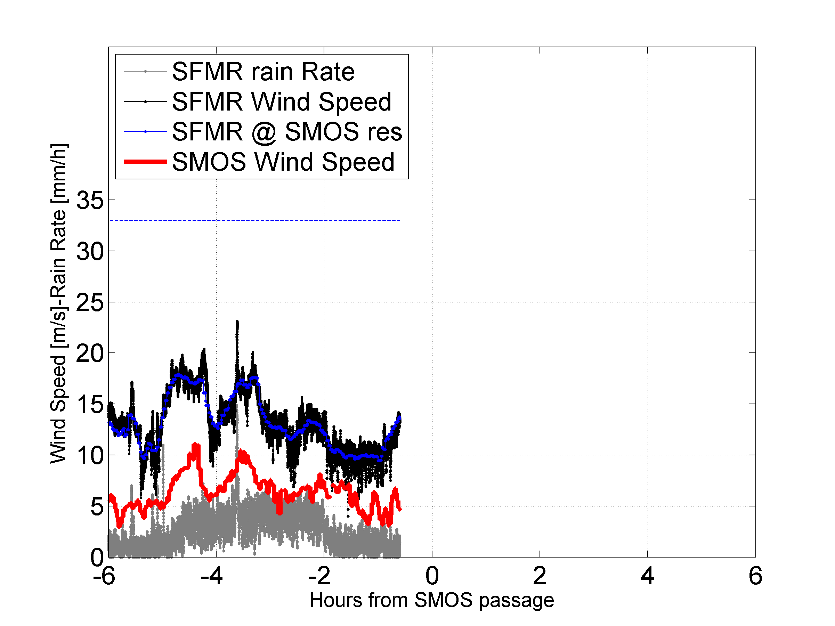

### Hurricane Danielle 21-20 August 2010

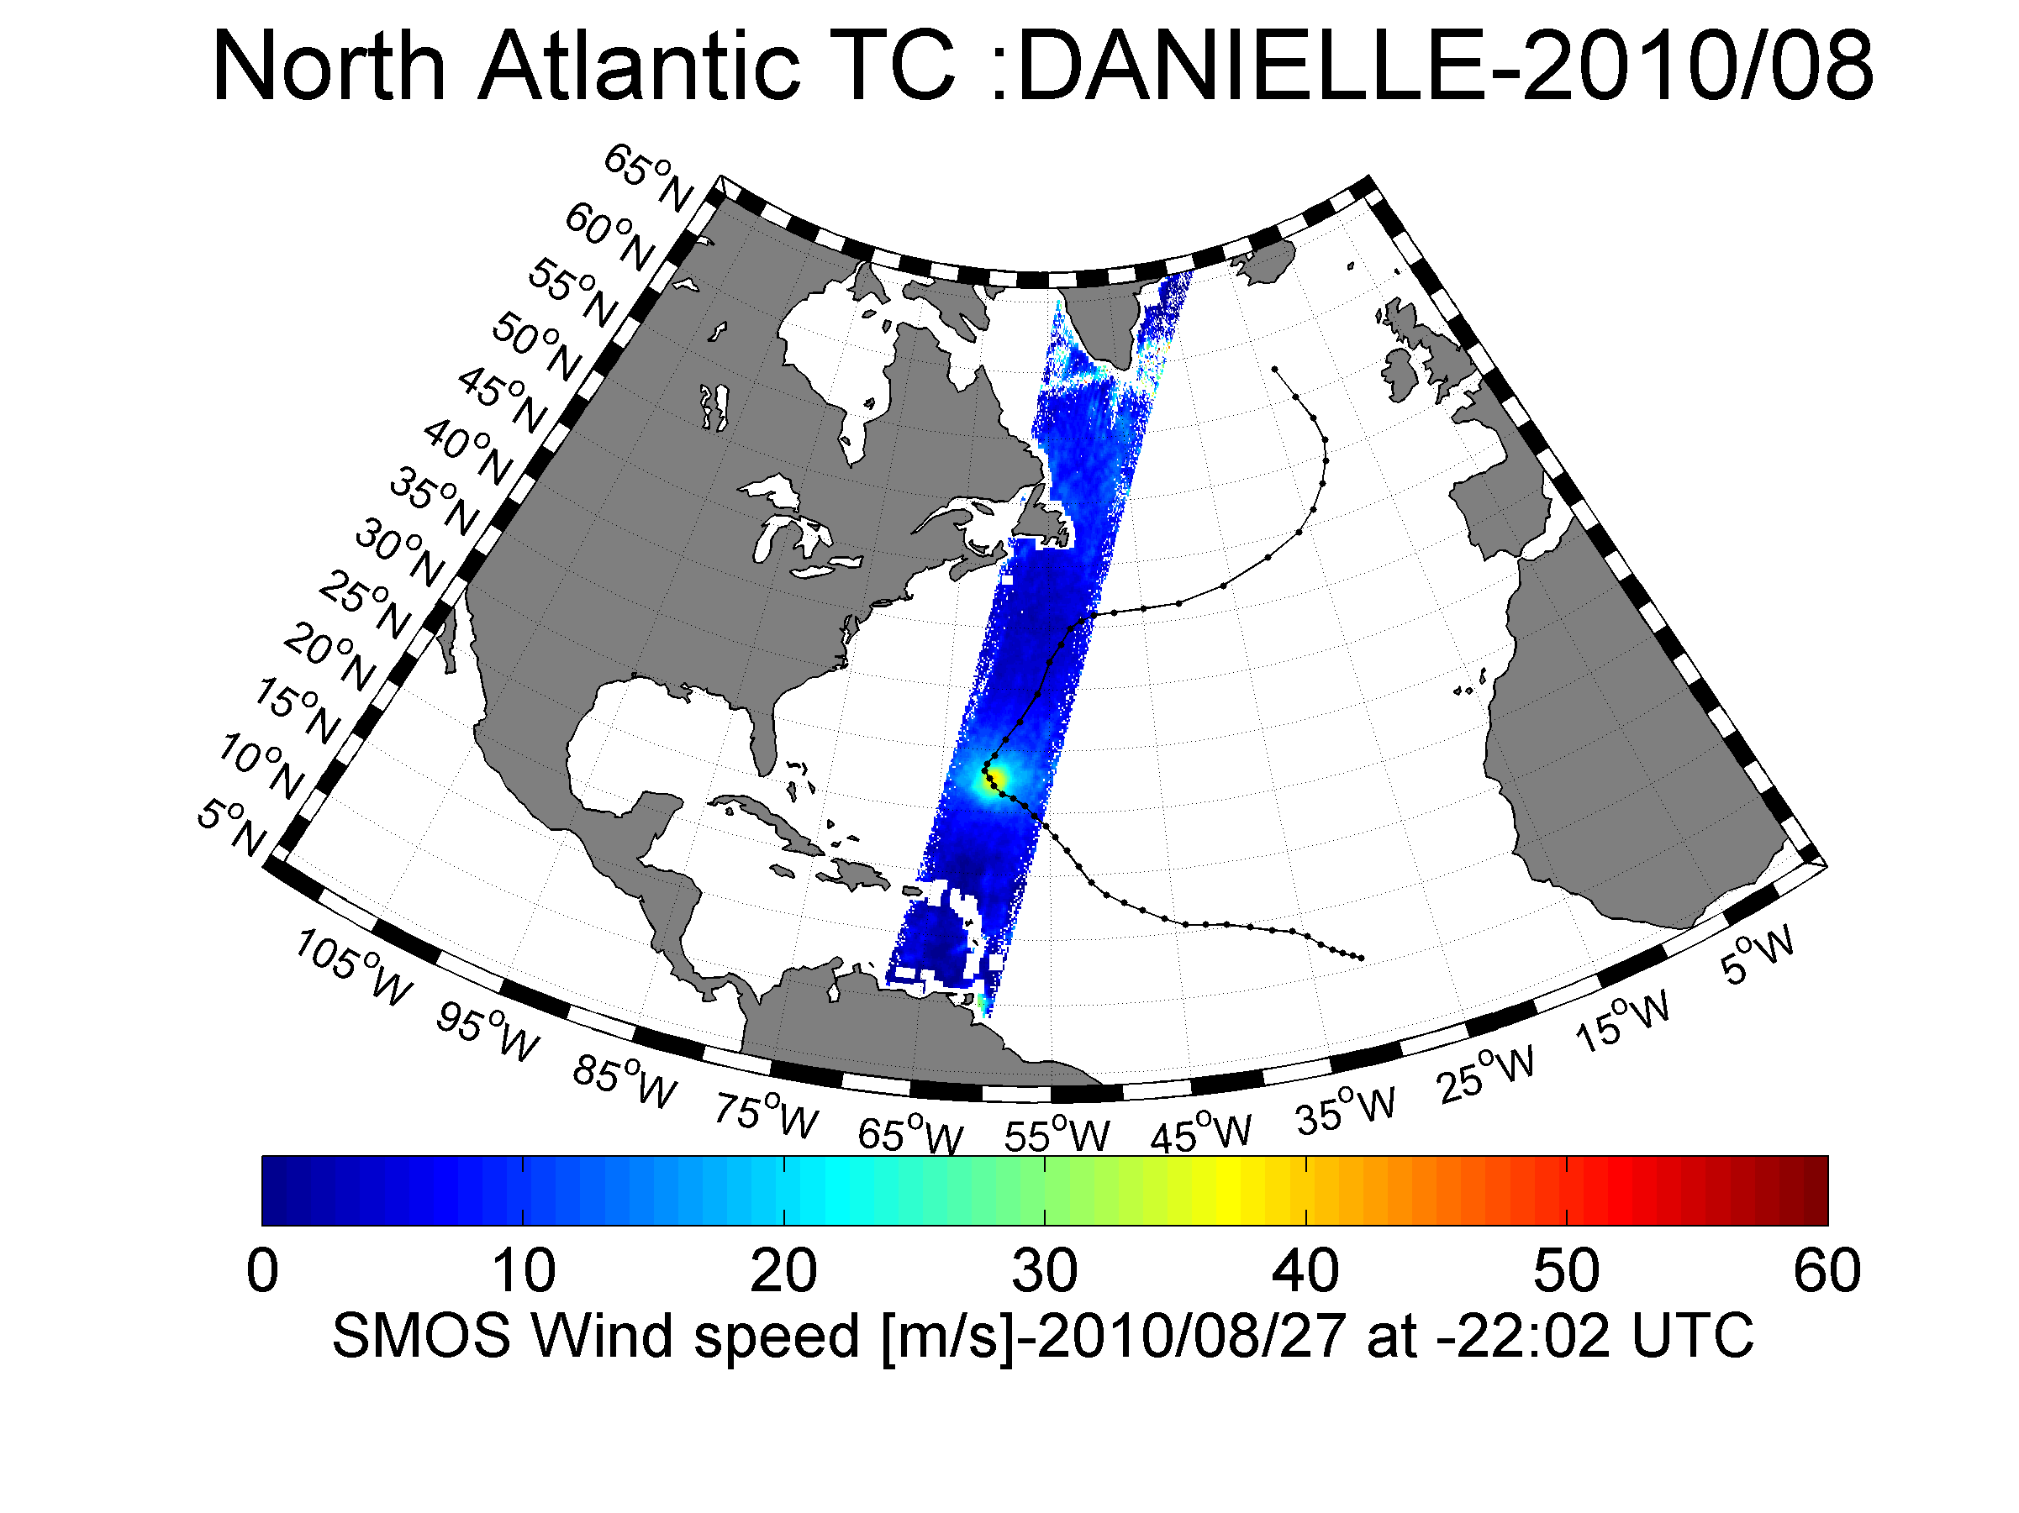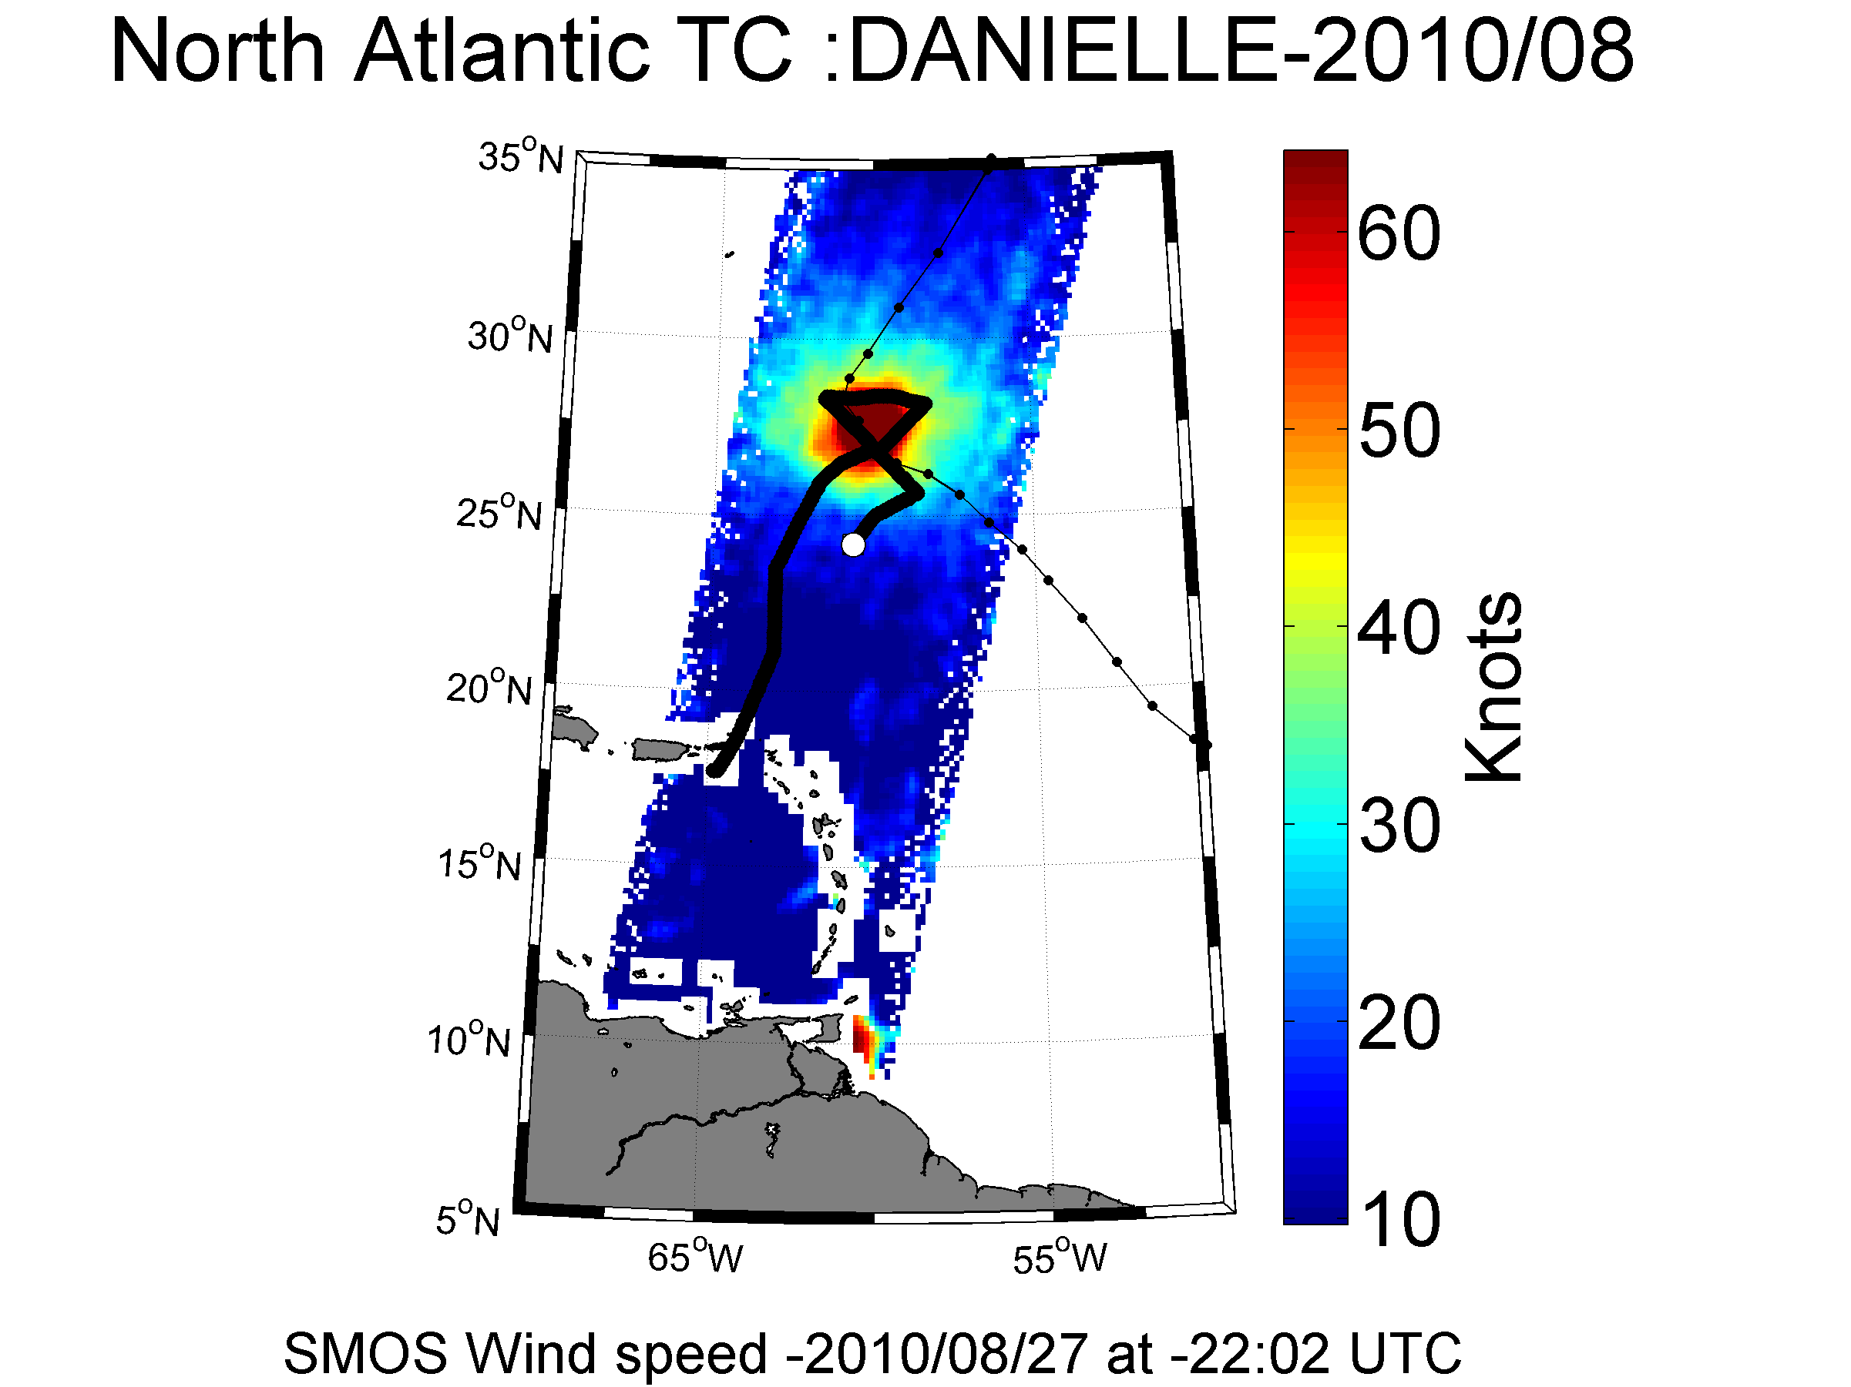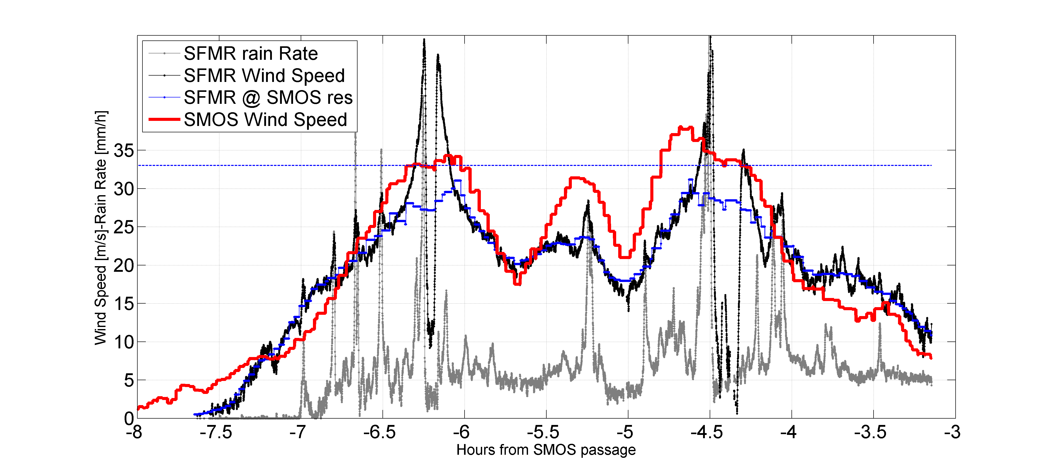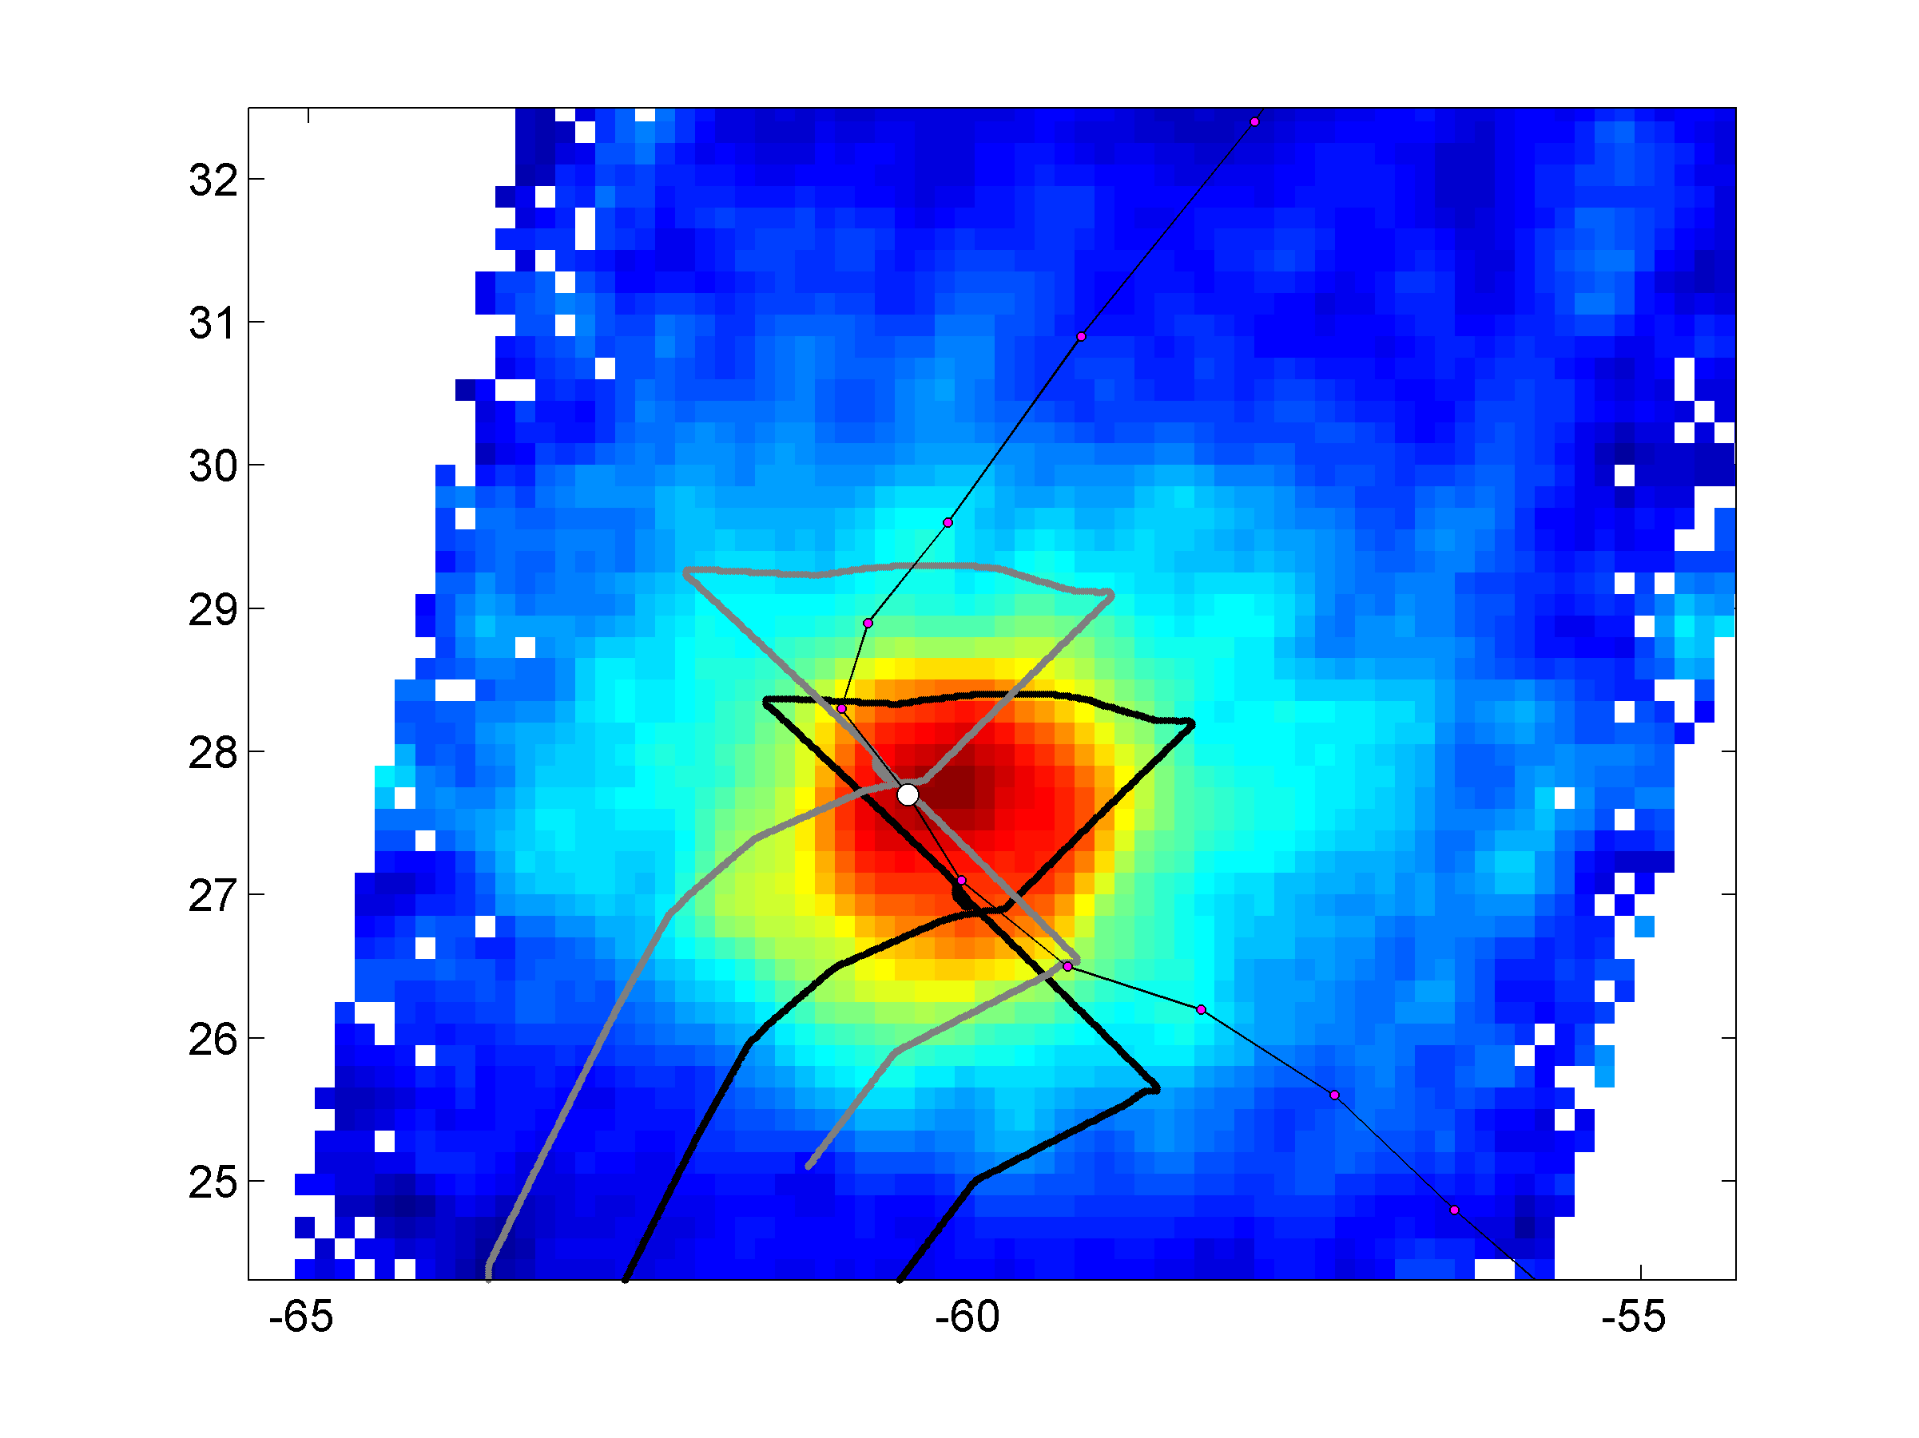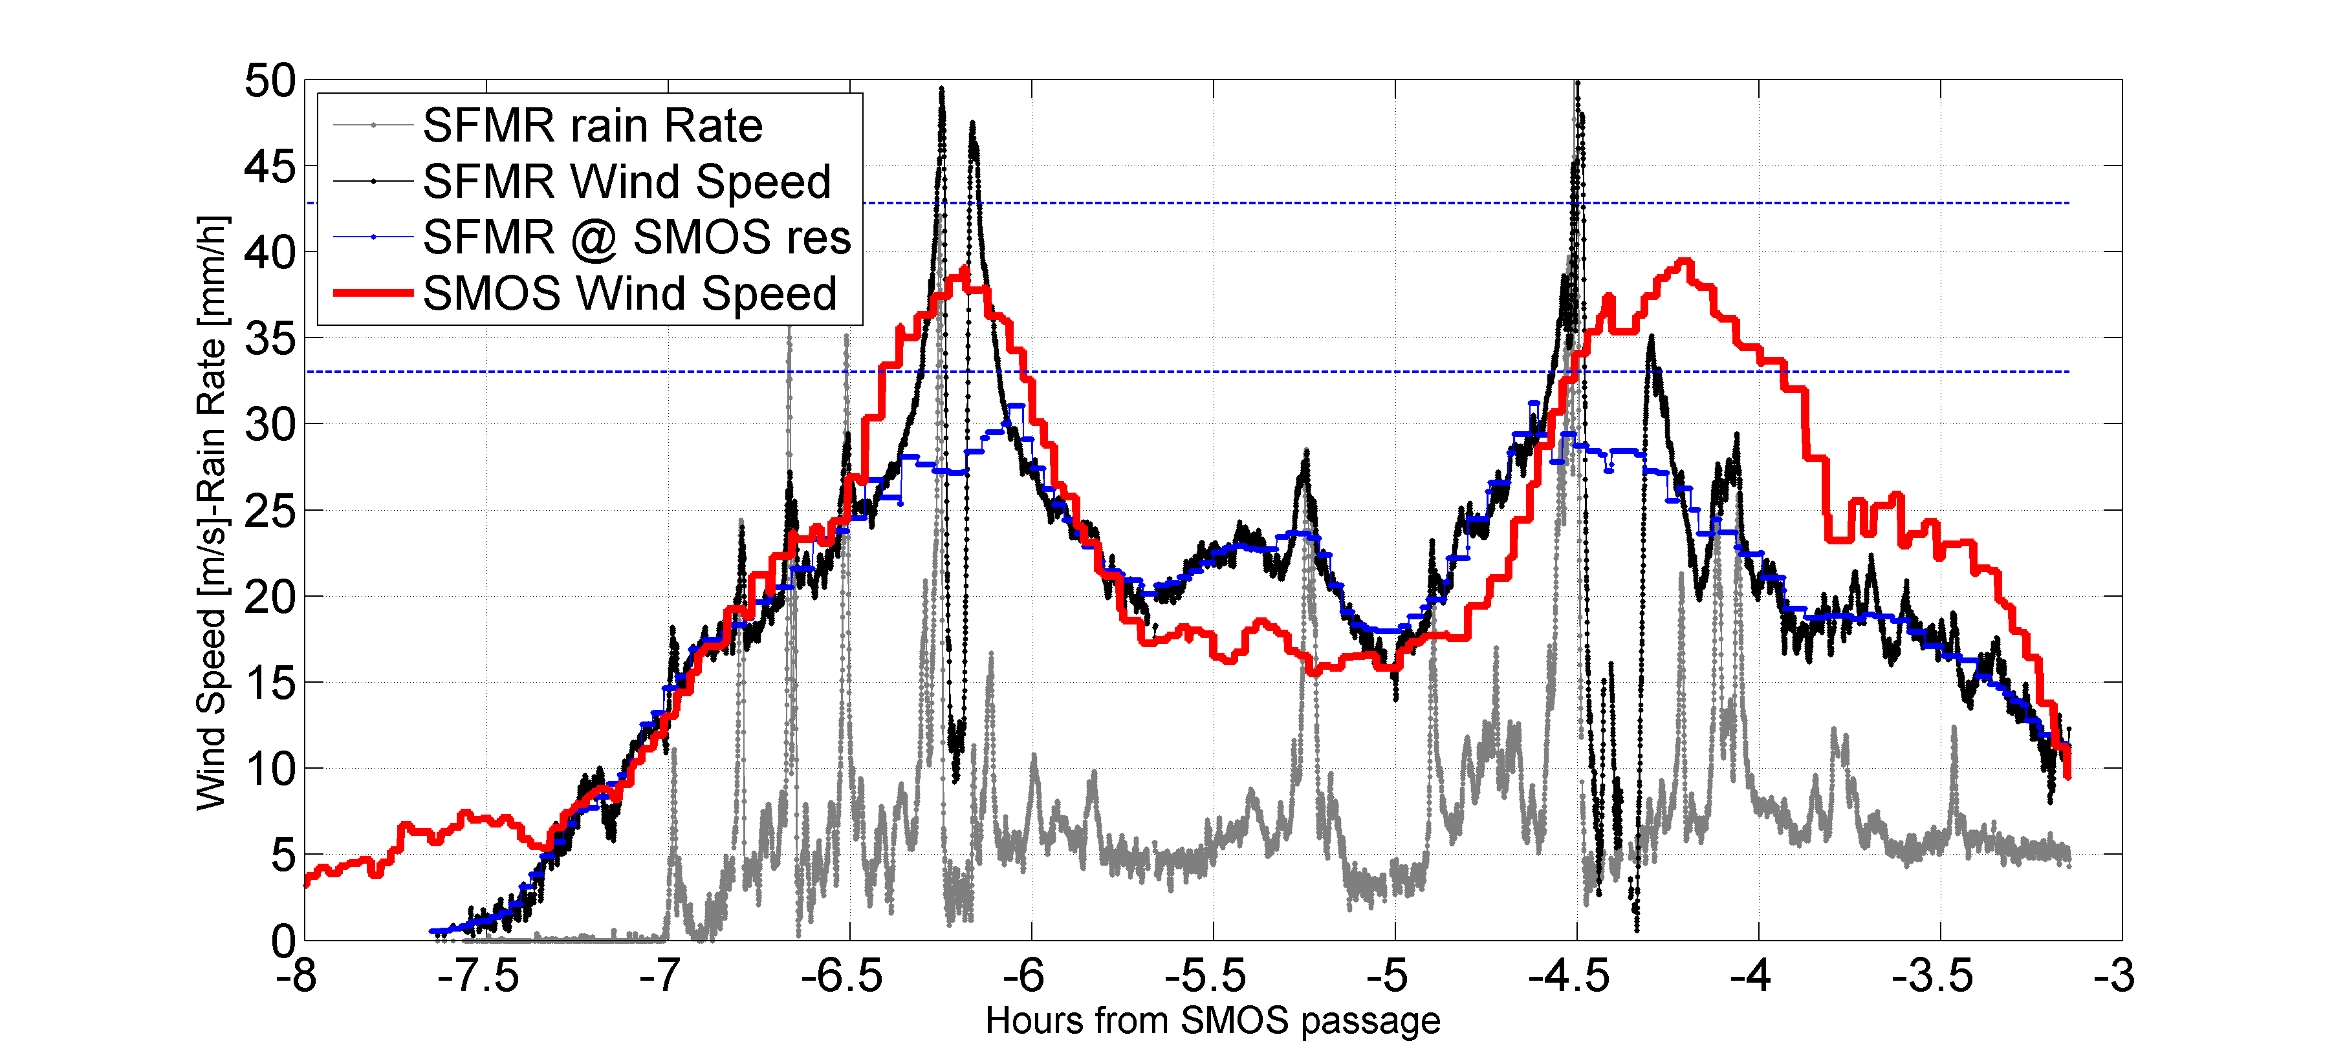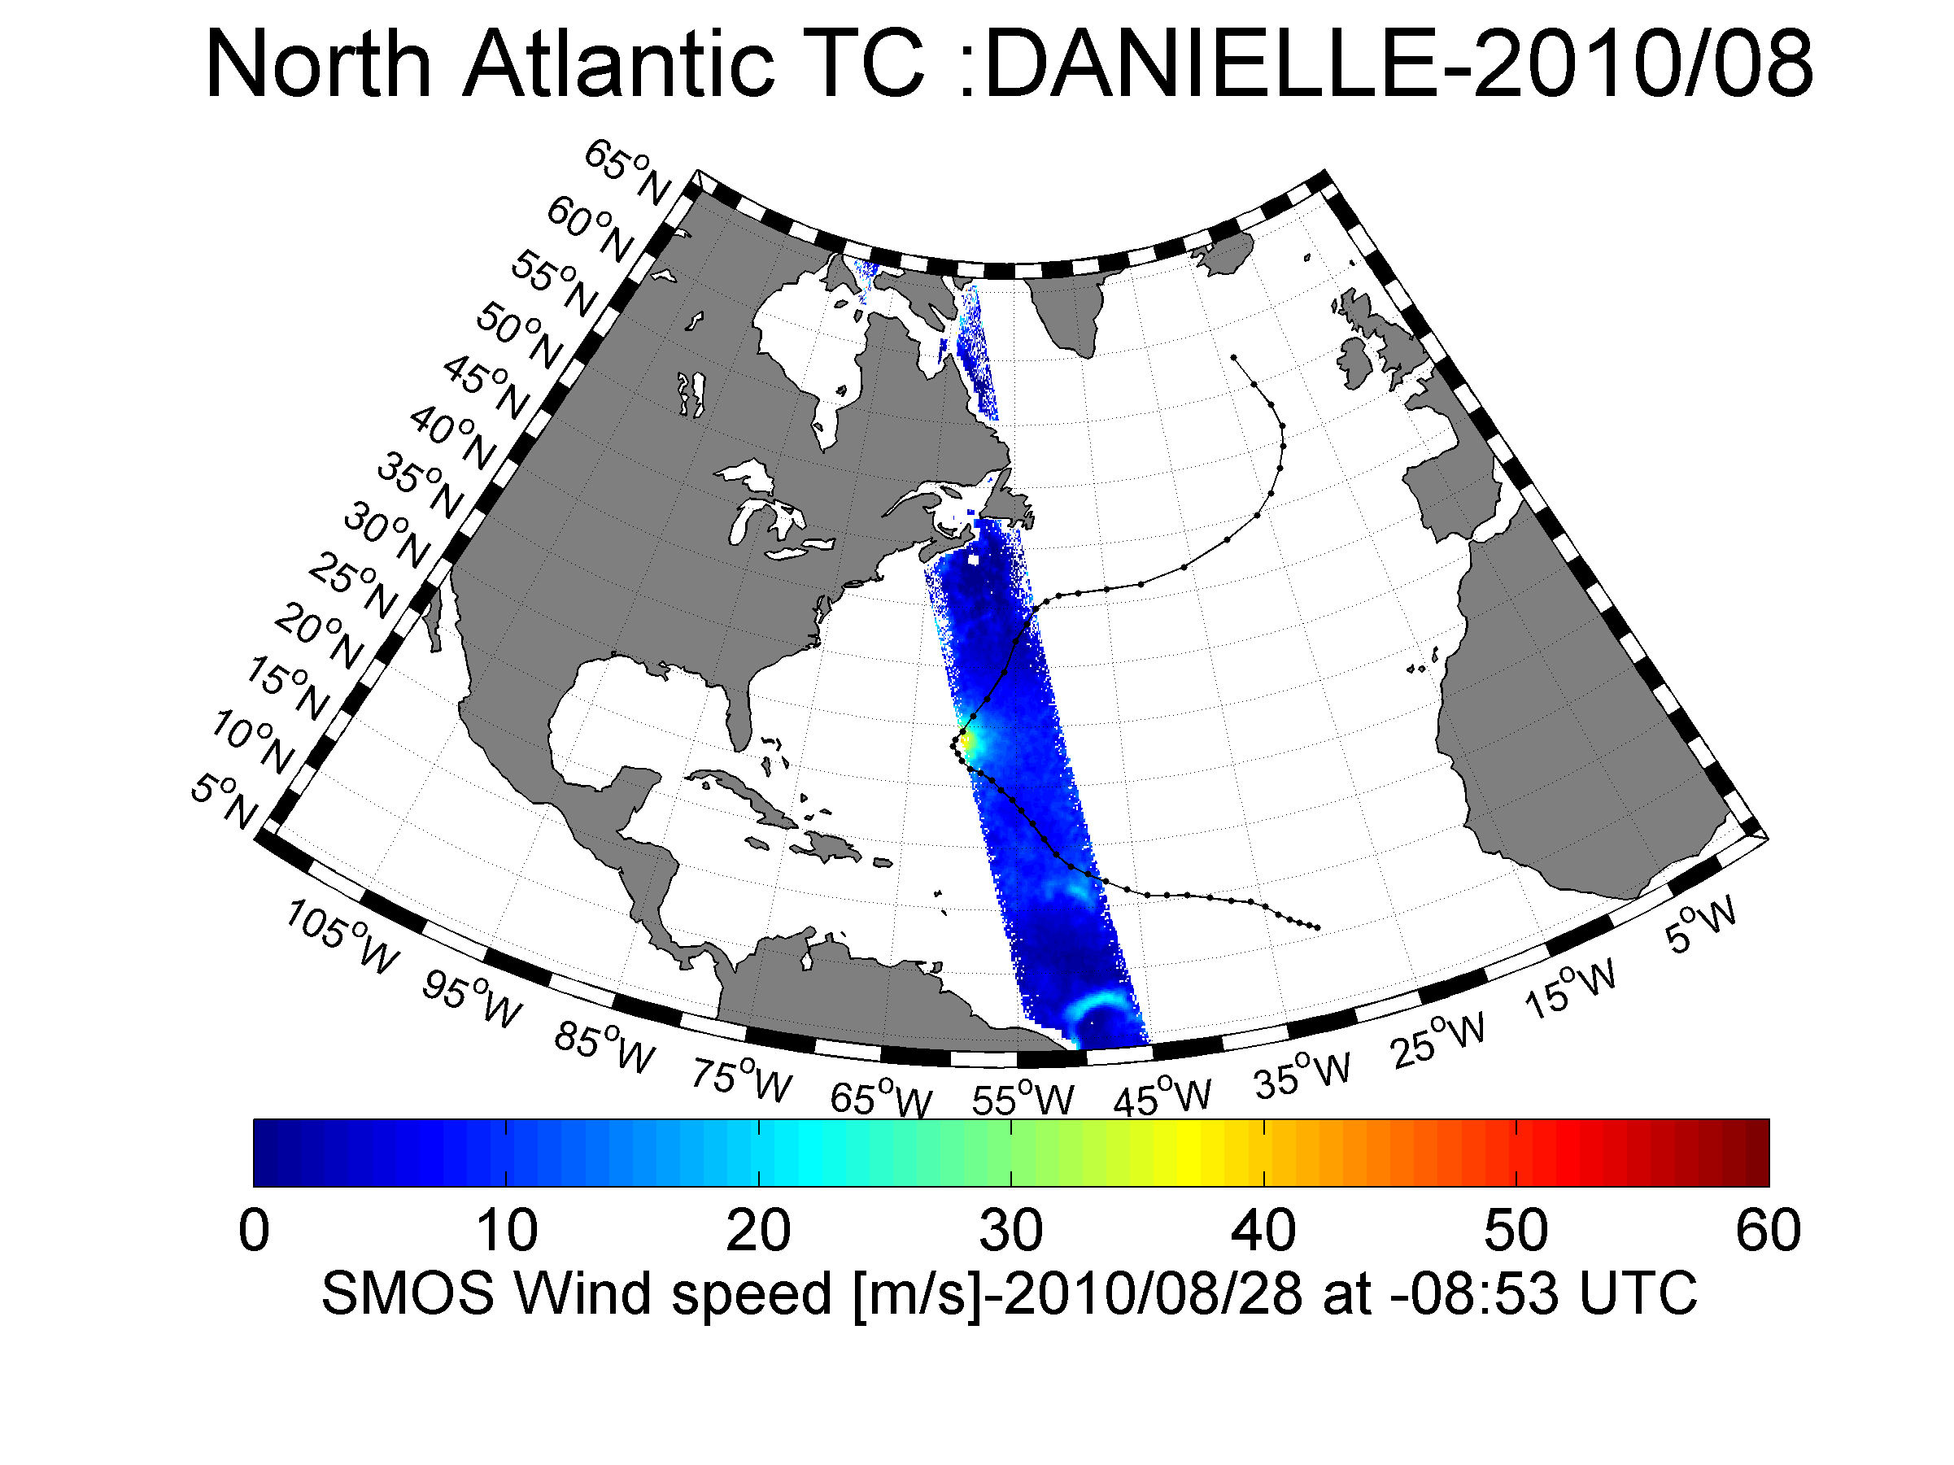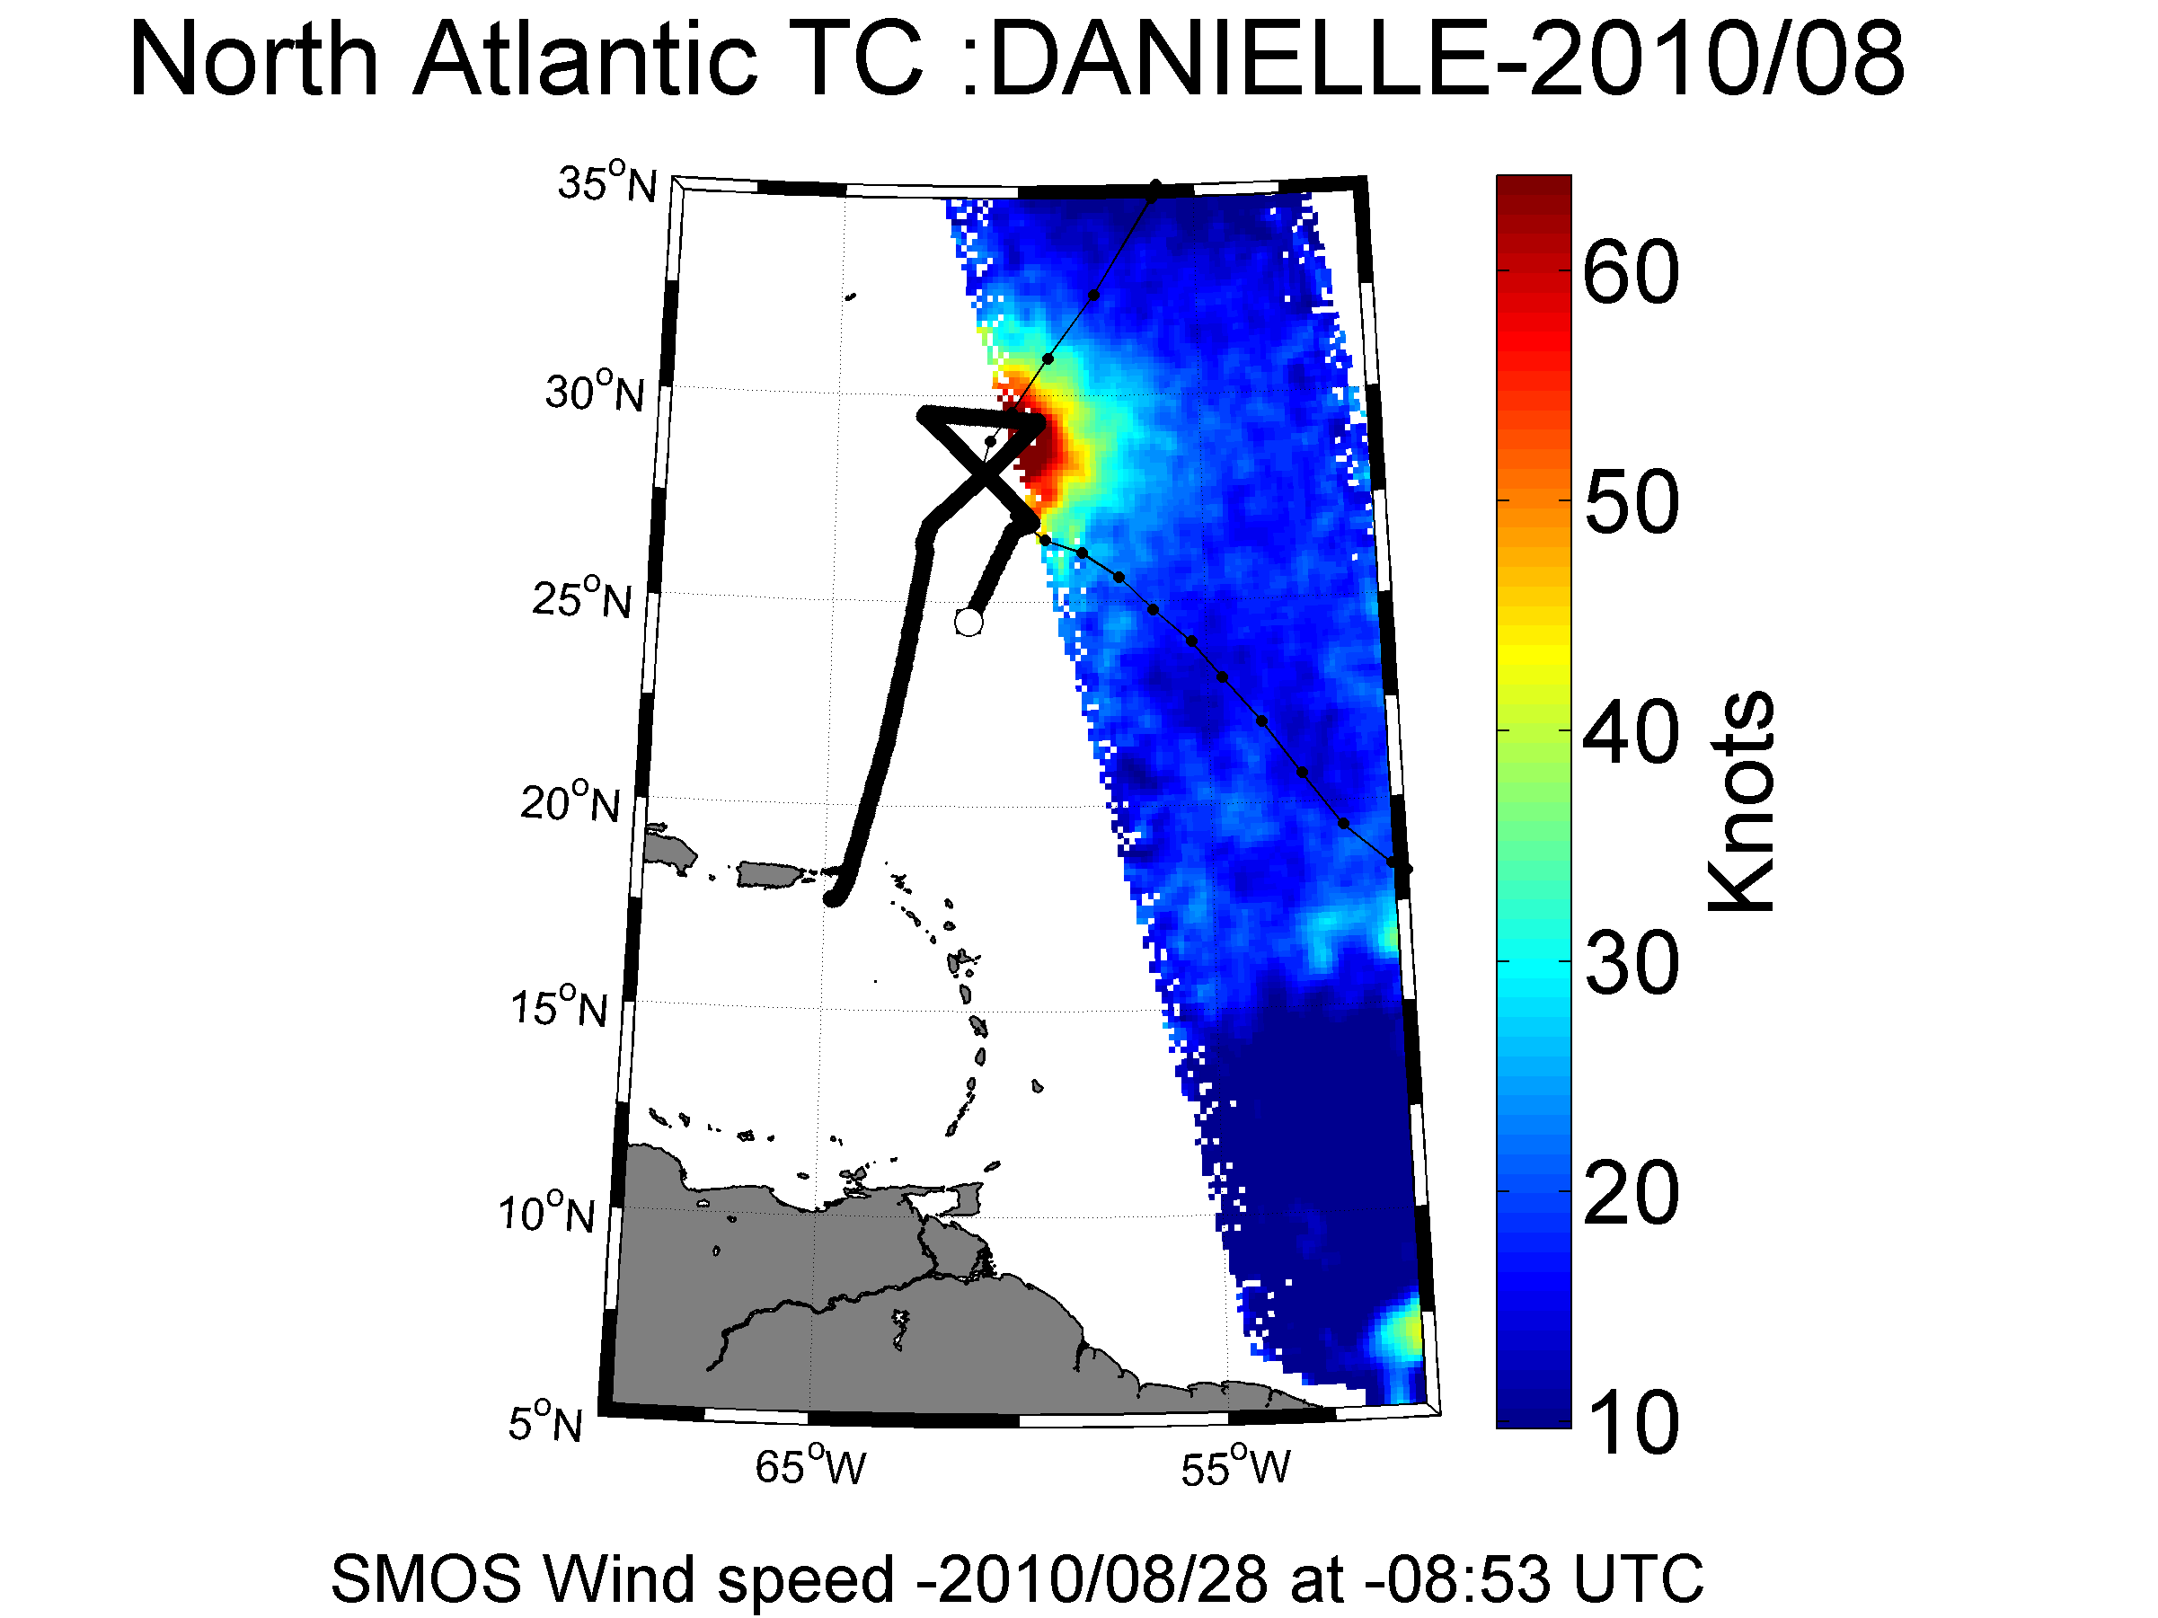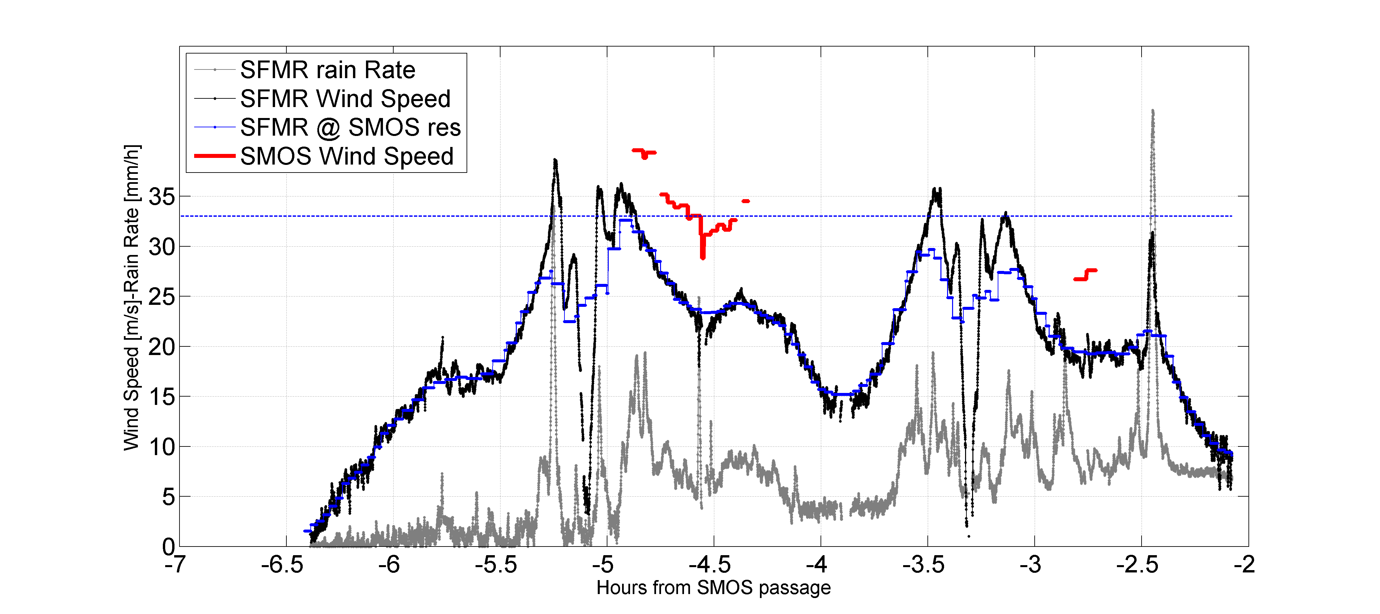

Hurricane Arthur 2014

### Hurricane Earl (Category 4)

(AL072010)

25 August - 4 September 2010

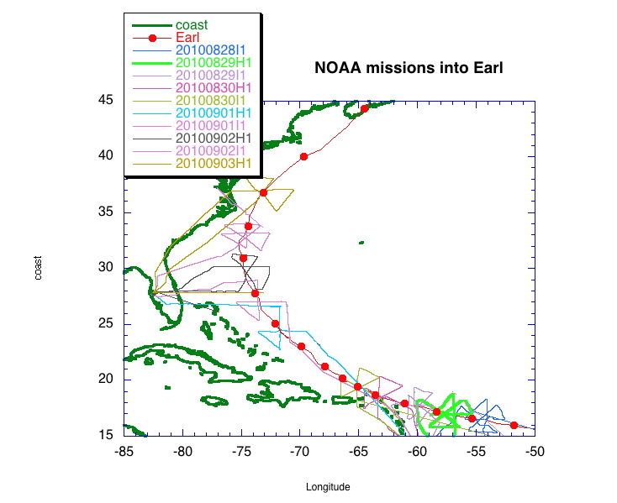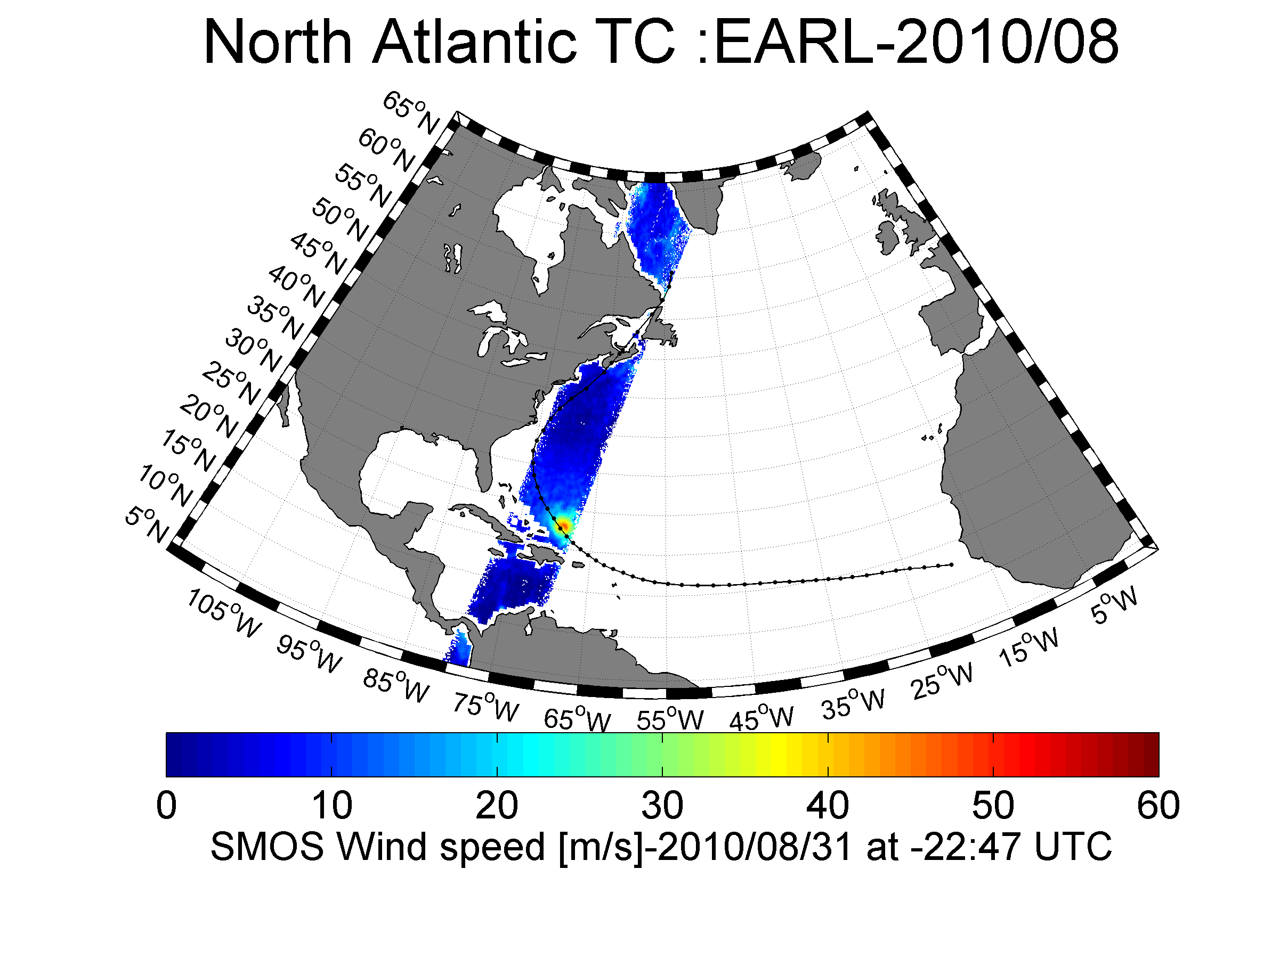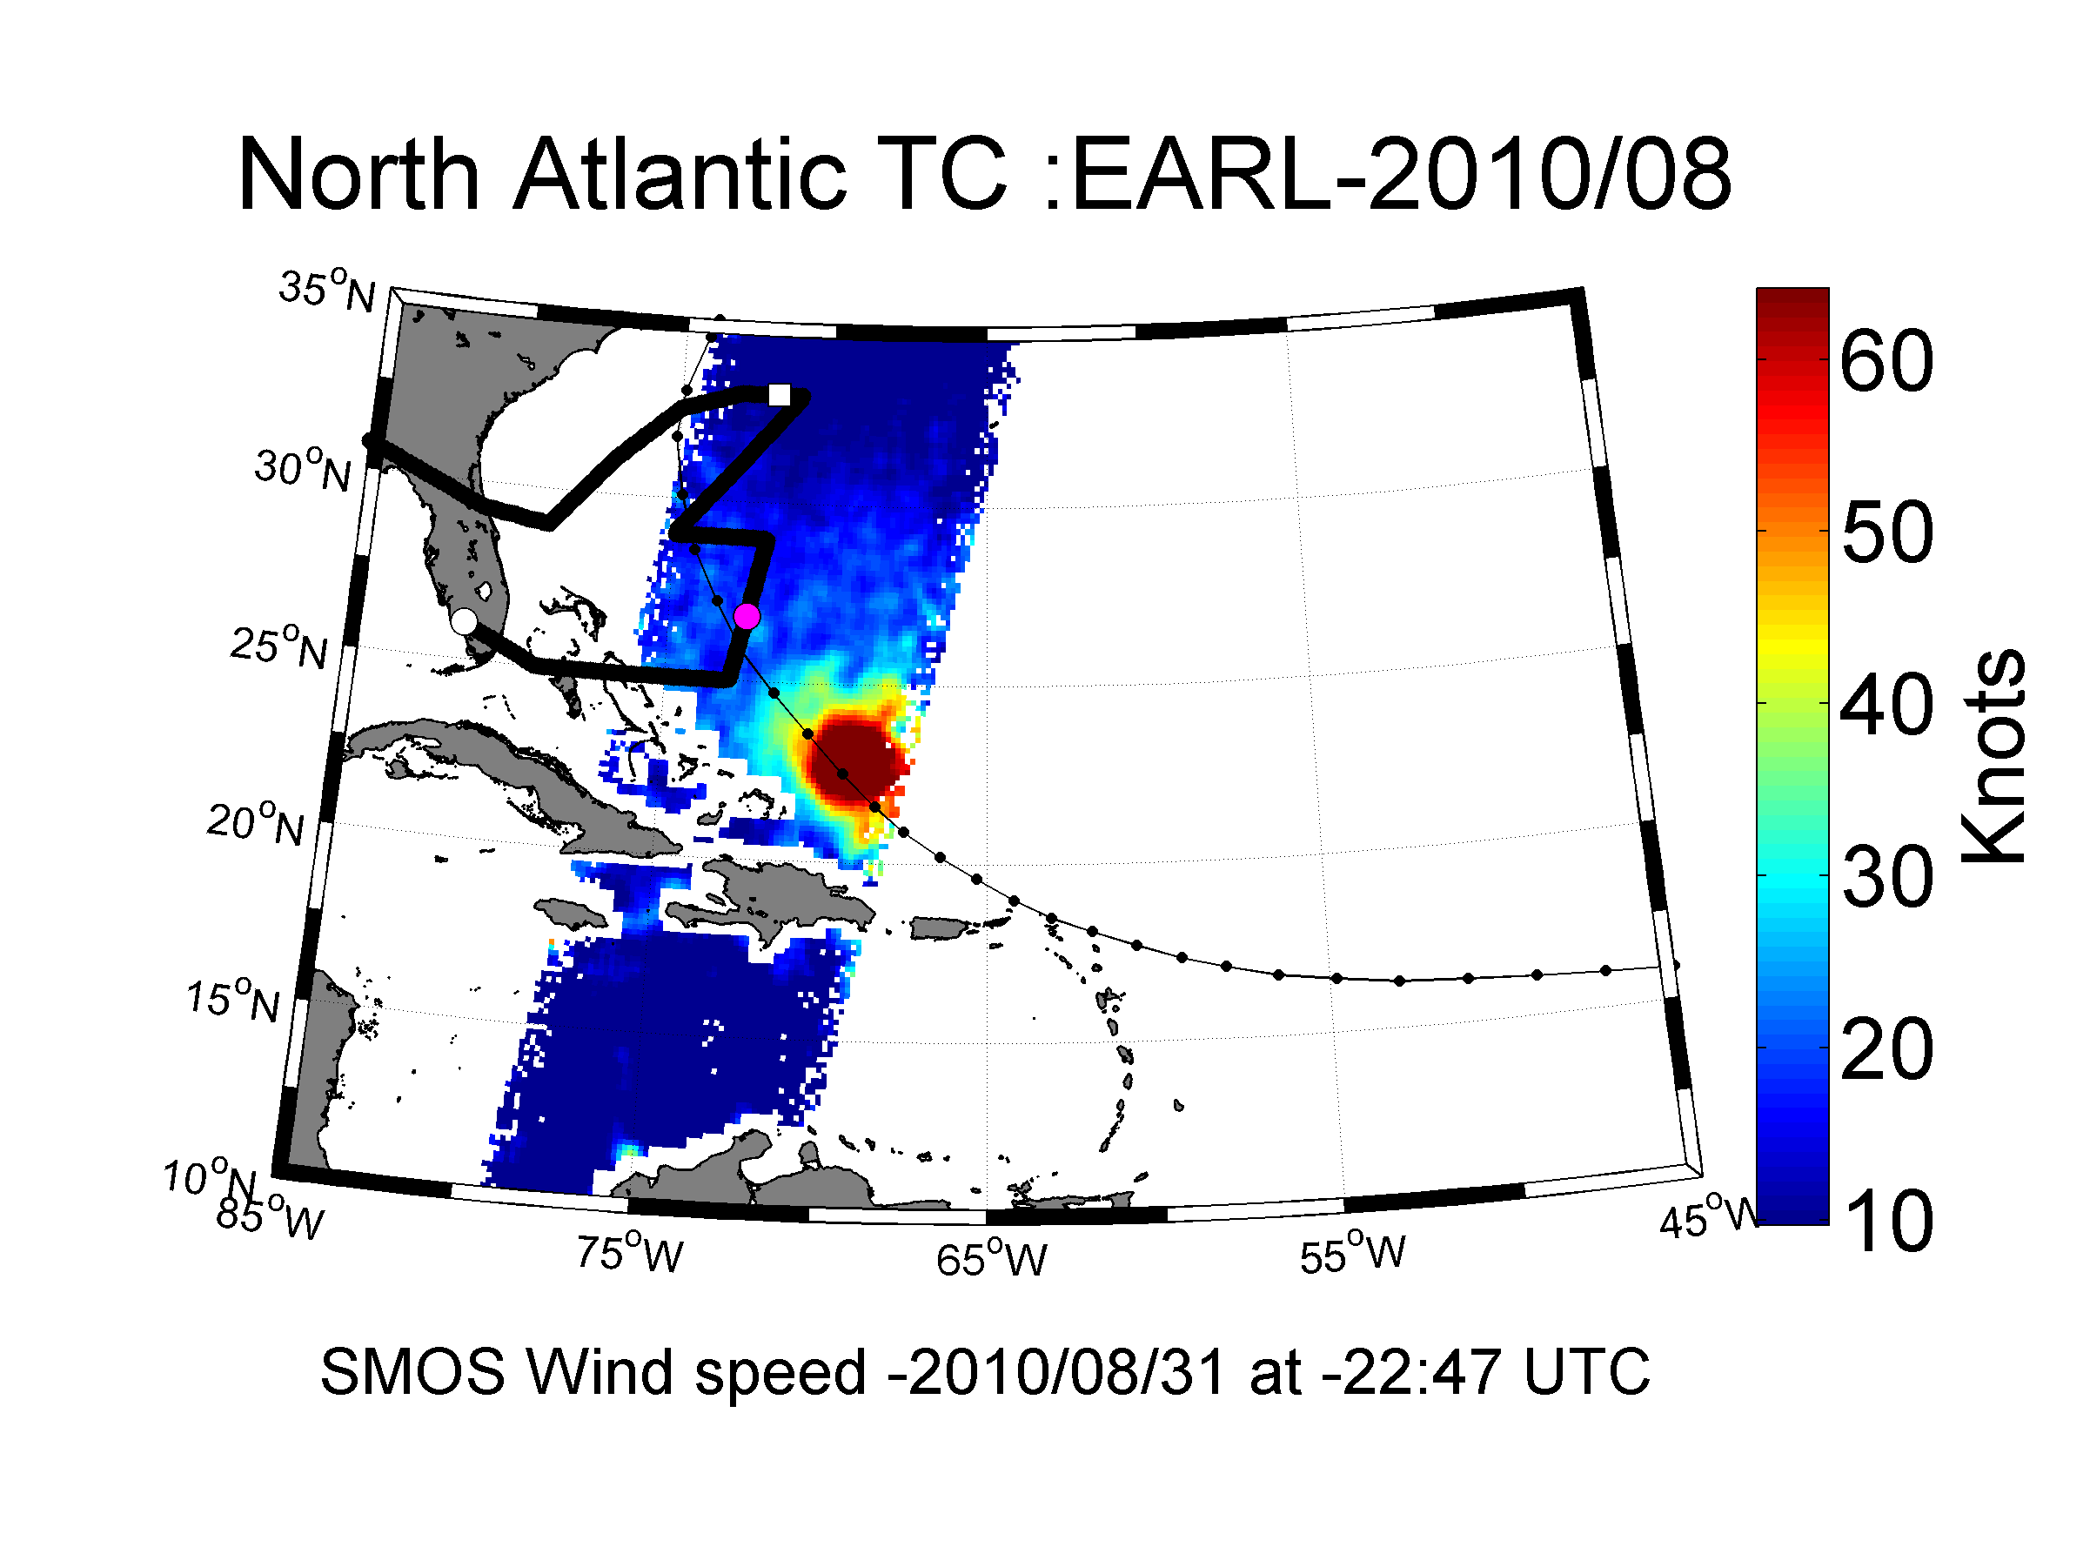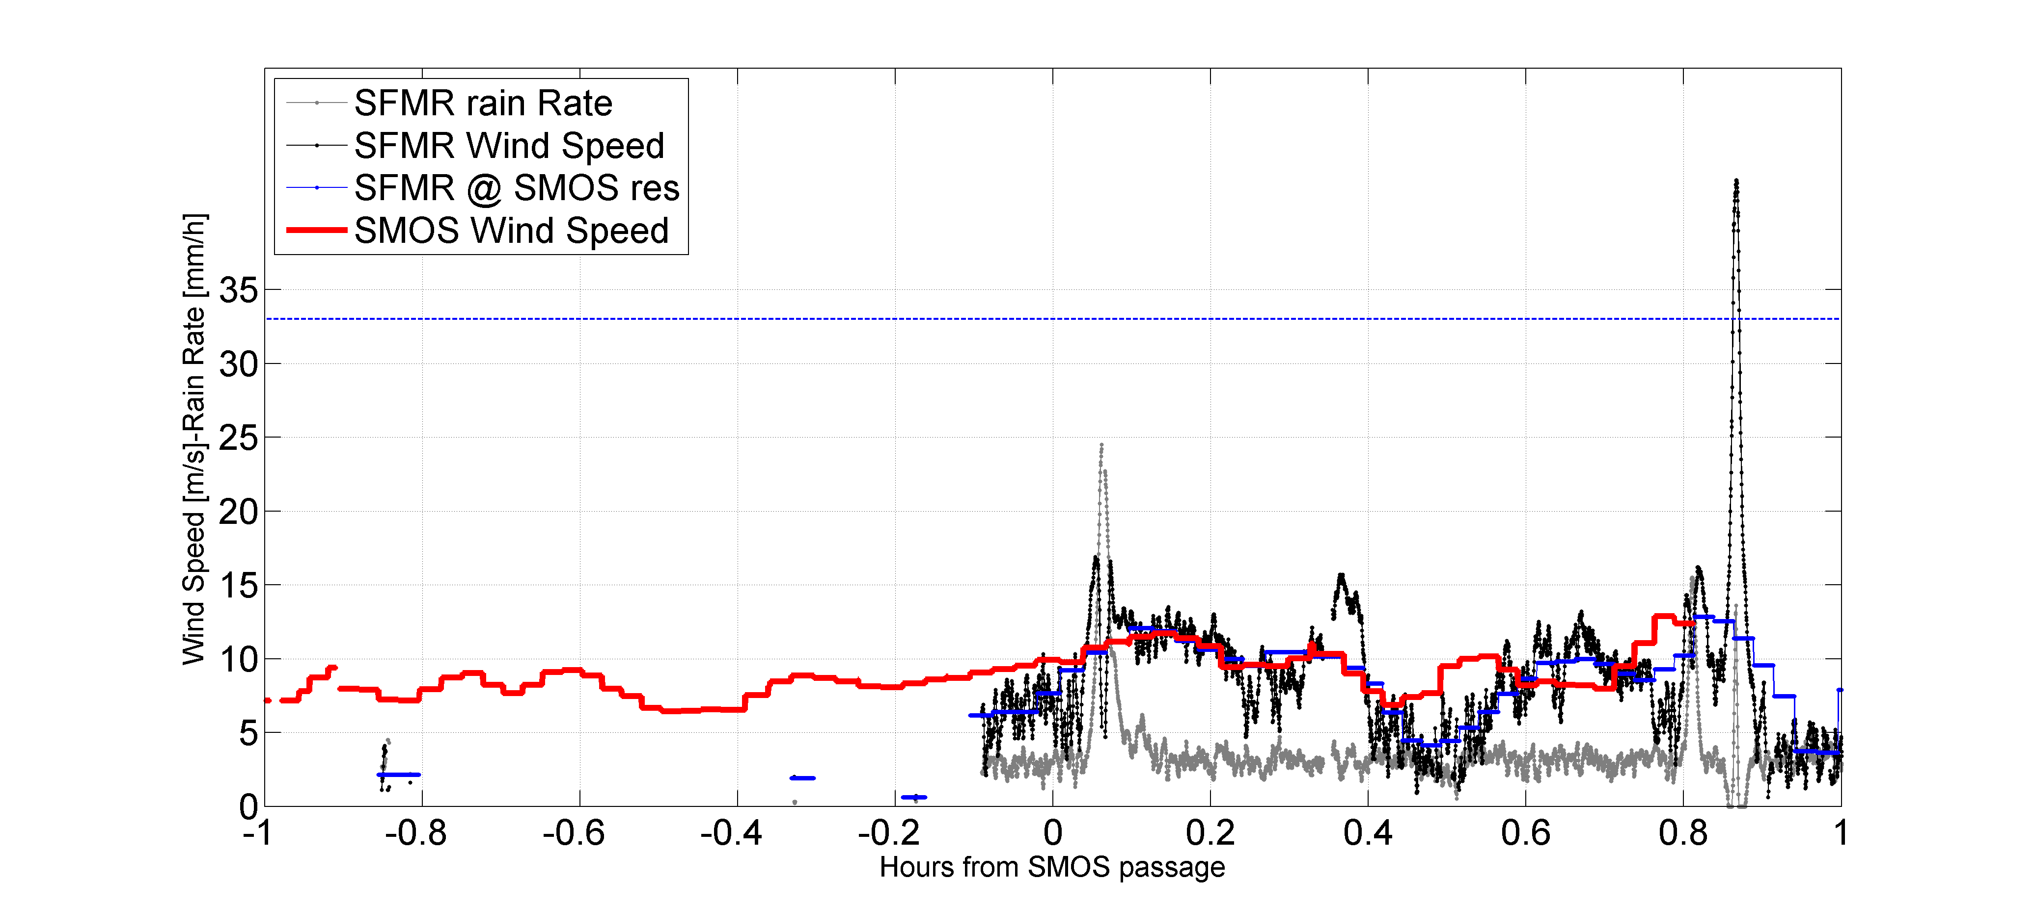

## North Atlantic Hurricane Season 2011

### Tropical Storm Colin

## North Atlantic Hurricane Season 2012

### Tropical Storm Colin

## North Atlantic Hurricane Season 2013

### Tropical Storm Colin

## North Atlantic Hurricane Season 2014

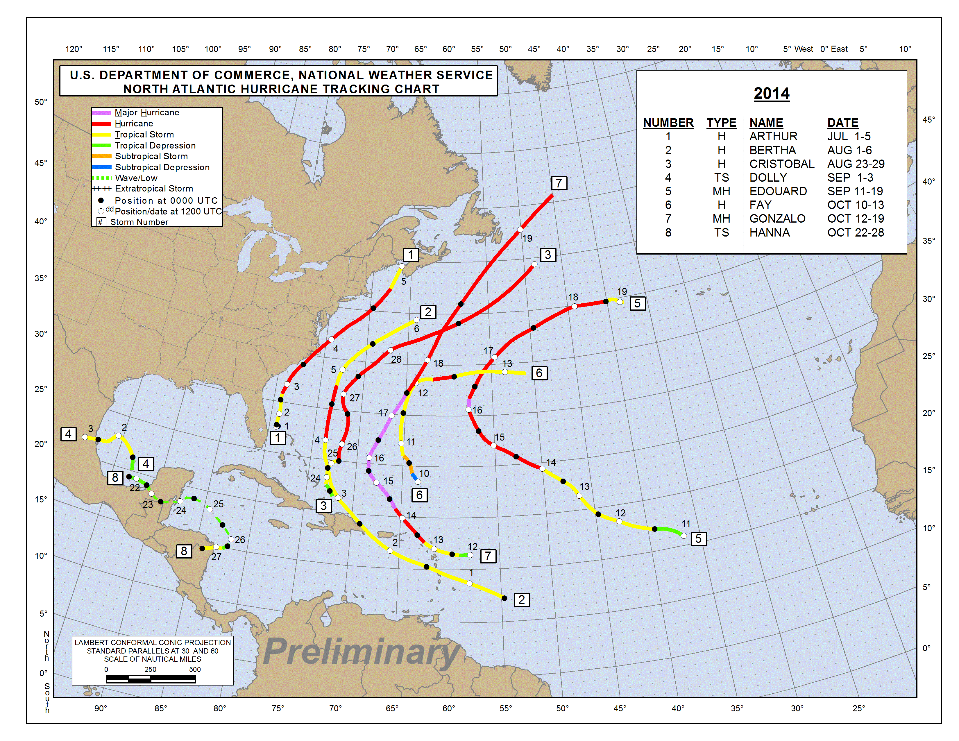

### Hurricane Arthur



|  |  |  |  |  |  |  |  |
| --- | --- | --- | --- | --- | --- | --- | --- |
| **Flight Ref Time of Flight SFMR SMOS** | | | | | | | |
| **July 02, 2014** | | | | | | | |
| [NOAA 42 (0501A)](http://www.aoml.noaa.gov/hrd/Storm_pages/arthur2014/20140702H1.html) | 06:04-12:59 Z | | TDR | [SFMR](ftp://ftp.aoml.noaa.gov/hrd/pub/data/sfmr/2014/arthur/NOAA_SFMR20140702H1.nc) | | | No SMOS |
| [NOAA 43 (0801A)](http://www.aoml.noaa.gov/hrd/Storm_pages/arthur2014/20140702I1.html) | 18:12-01:27 Z | | TDR | [SFMR](ftp://ftp.aoml.noaa.gov/hrd/pub/data/sfmr/2014/arthur/NOAA_SFMR20140702I1.nc) | | | No SMOS |
| **July 03, 2014** | | | | | | | |
| [NOAA 42 (1001A)](http://www.aoml.noaa.gov/hrd/Storm_pages/arthur2014/20140703H1.html) | 06:28-14:08 Z | TDR | | | [SFMR](ftp://ftp.aoml.noaa.gov/hrd/pub/data/sfmr/2014/arthur/NOAA_SFMR20140703H1.nc) | Flight#1 over  SMOS (2014 /07/03) at 10:41 UTC | |
| [NOAA 43 (1301A)](http://www.aoml.noaa.gov/hrd/Storm_pages/arthur2014/20140703I1.html) | 17:15-23:43 Z | TDR | | | [SFMR](ftp://ftp.aoml.noaa.gov/hrd/pub/data/sfmr/2014/arthur/NOAA_SFMR20140703I1.nc) | Flight#2 over  SMOS (2014/07/03) at 23:13_UTC | |
| **July 05, 2014** | | | | | | | |
| [NOAA 42 (1801A)](http://www.aoml.noaa.gov/hrd/Storm_pages/arthur2014/20140705H1.html) | 06:13-15:54 Z | TDR | | | [SFMR](ftp://ftp.aoml.noaa.gov/hrd/pub/data/sfmr/2014/arthur/NOAA_SFMR20140705H1.nc) | | Flight#3 over Arthur and SMOS:  SMOS (2014/07/05) at 09:23_UTC.png |

#### Co_localized Flight#1 over Hurricane Arthur 2014/07/03 at 10:41 UTC

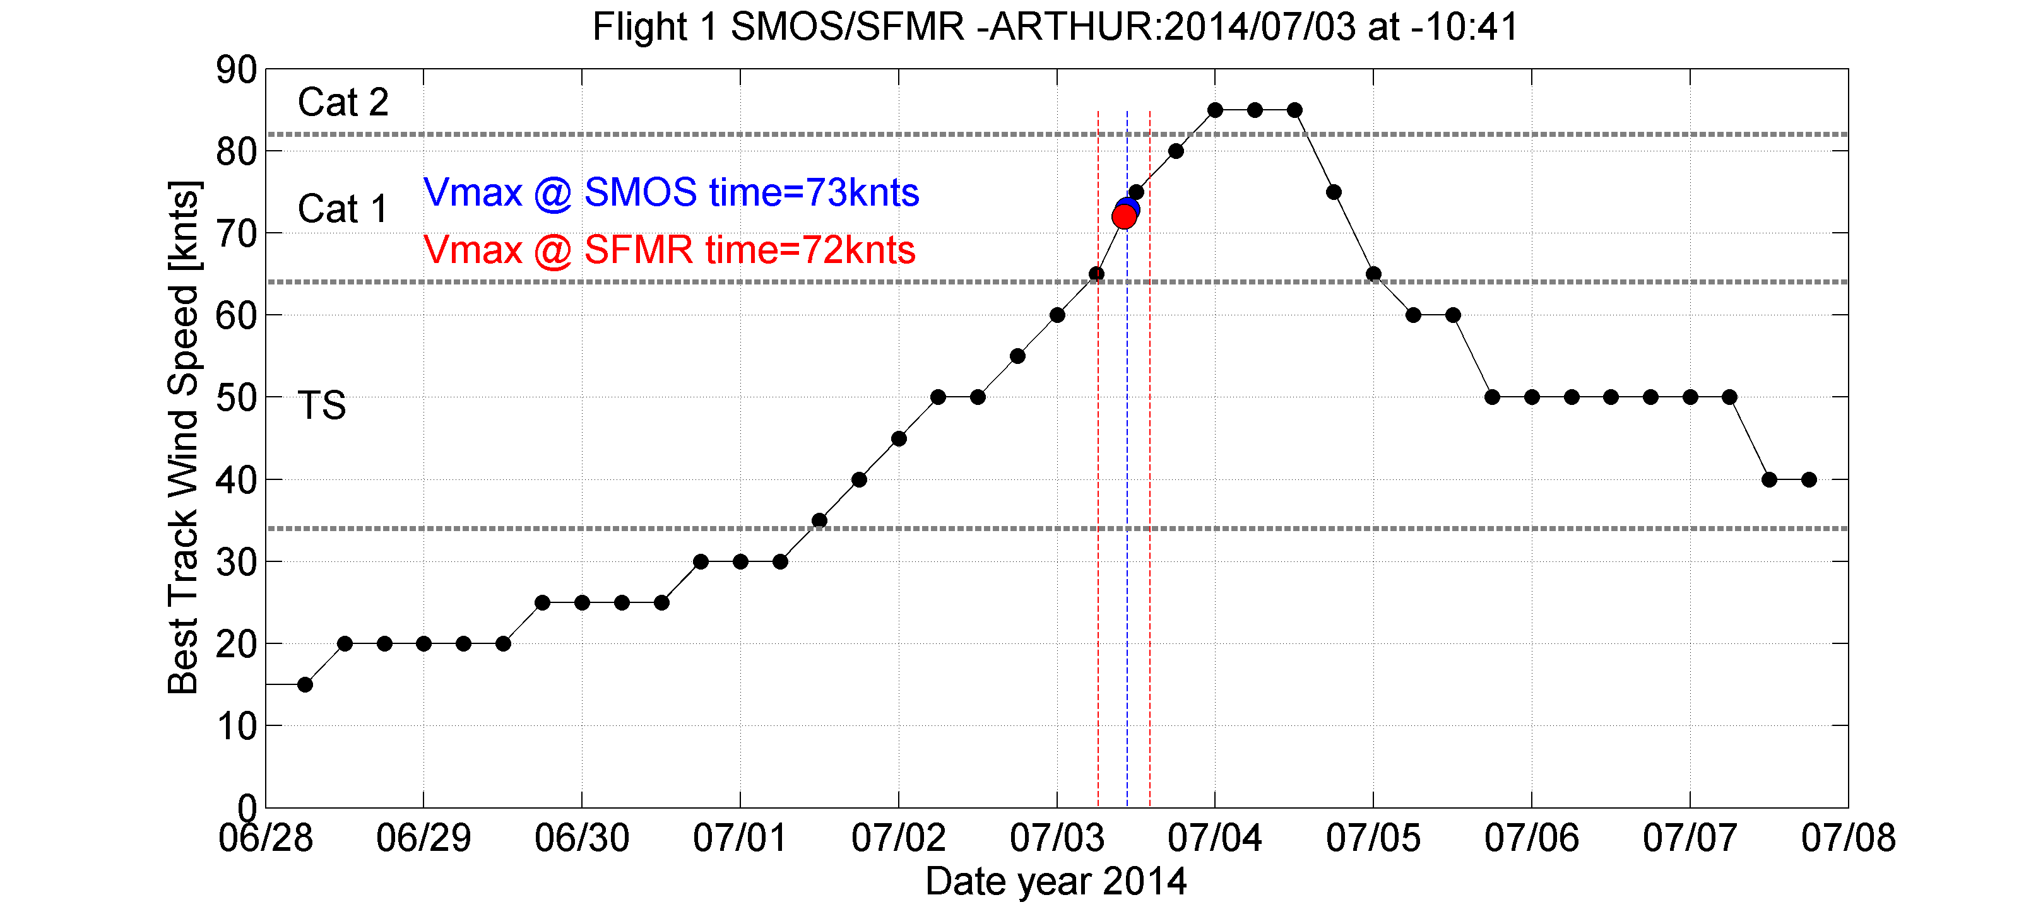

Figure: Best track maximum sustained surface wind speed (black dash dotted curve) for Hurricane Arthur, 1-5 July 2014. Red vertical lines delineates the duration of SFMR flight#1 ([NOAA 42 (1001A)](http://www.aoml.noaa.gov/hrd/Storm_pages/arthur2014/20140703H1.html)) while blue indicate time of SMOS overpass. The red and blue dots indicate the maximum wind speed at SFMR flight and SMOS pass mean acquisition times, respectively.

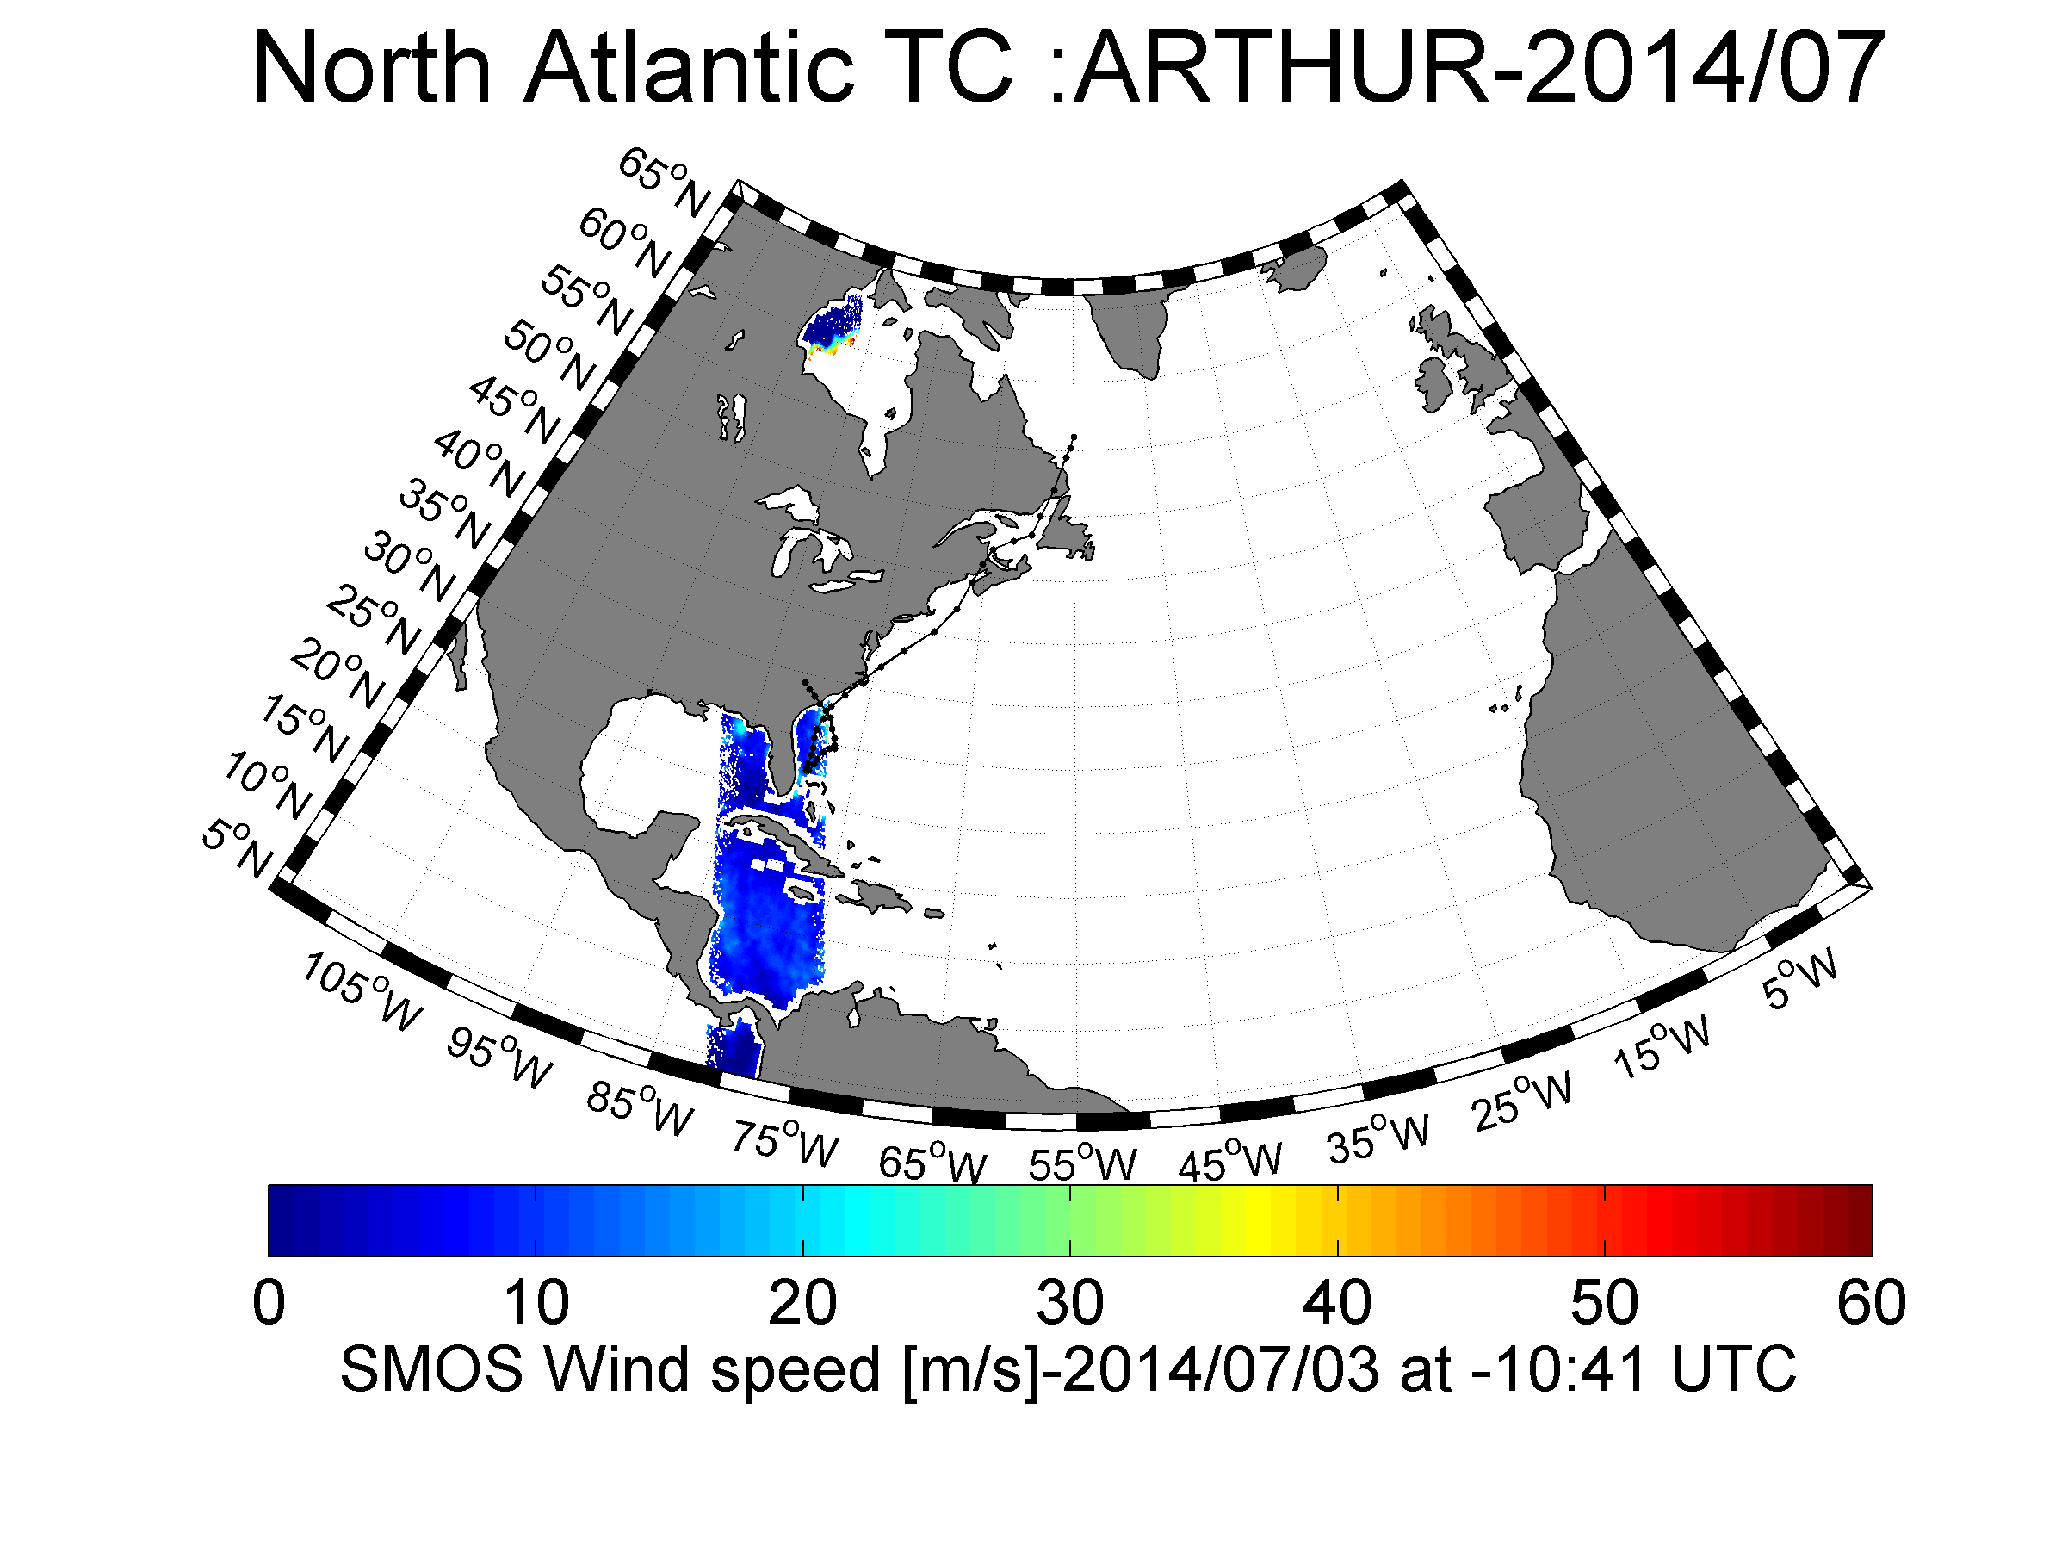

Figure: Overview of the SMOS retrieved wind speed field over Arthur on the 3 July 2014 at 10:41 UTC.

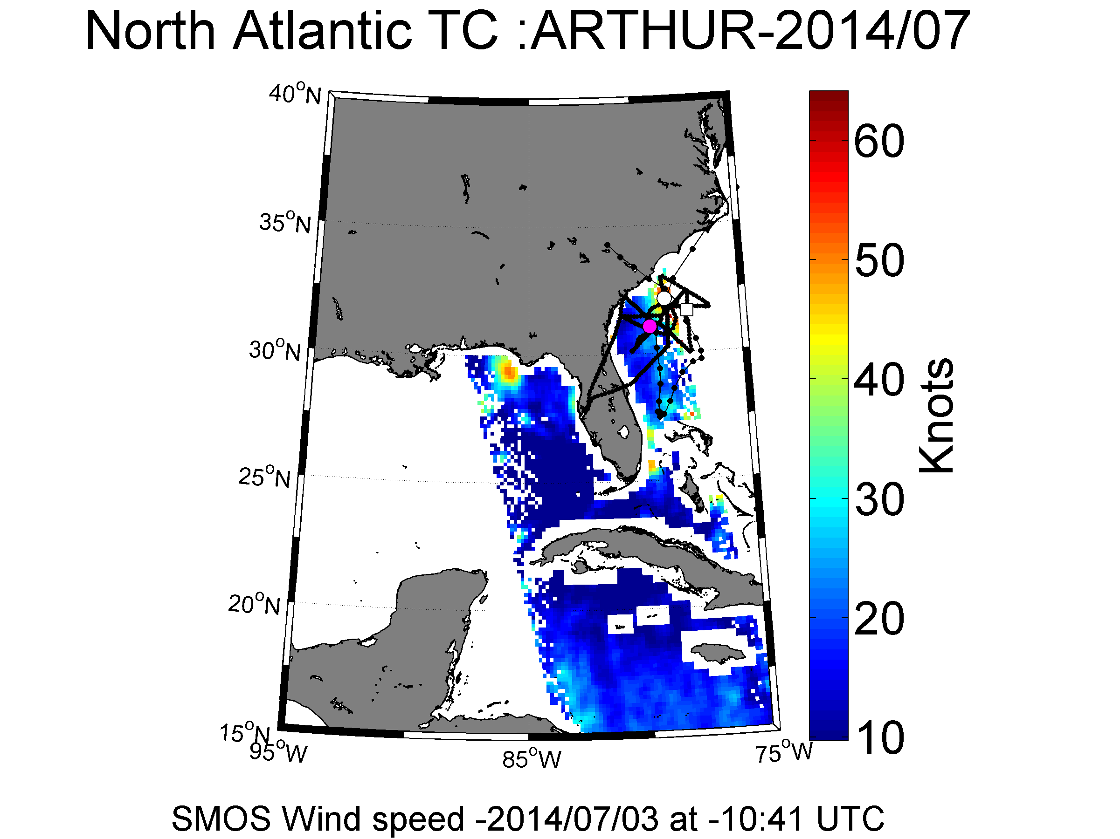

Figure: Blow up on the SMOS retrieved wind speed field over Arthur on the 3 July 2014 at 10:41 UTC. The black lines indicate the track of the SFMR flight. Pink dot indicates the location of the aircraft at SMOS acquisition time. The white dot and squares indicate the location of the aircraft +2 and -2 hours appart from SMOS acquisition time, respectively.

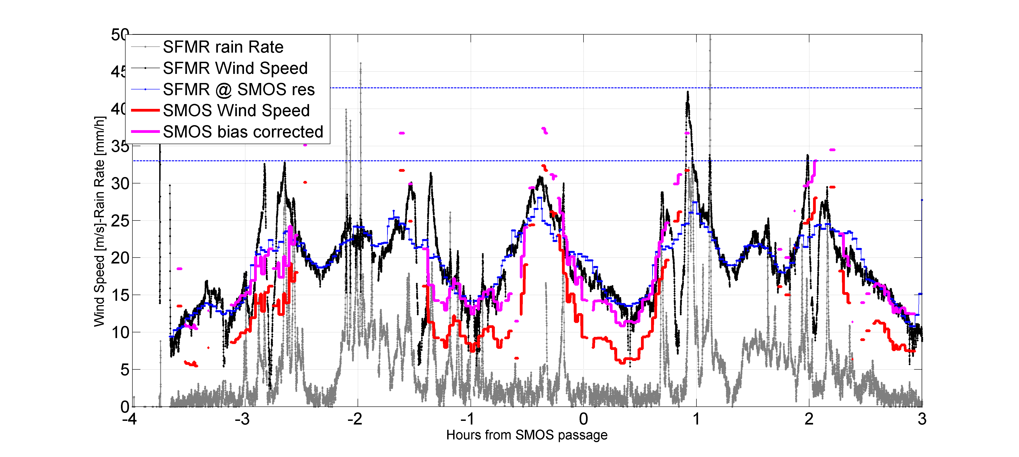

Figure: Time series of the SFMR rain rate (gray curve) and wind speed (black curve) along the aircraft track. The x-axis represent the time difference between SFMR and SMOS acquition in hours. SMFR wind speed is spatially averaged at SMOS spatial resolution (±15 km) and shown in blue. The red curve is showing SMOS wind speed retrieval interpolated along the aircraft ground track and using the first GMF version. The magenta curve is showing the same SMOS wind speed but offset to match the observations, here by +5 m/s.

Figure: Time series of the SFMR rain rate (gray curve) and wind speed (black curve) along the aircraft track. The x-axis represent the time difference between SFMR and SMOS acquition in hours. SMFR wind speed is spatially averaged at SMOS spatial resolution (±15 km) and shown by the blue curve. The red curve is showing SMOS incidence-angle averaged Brightness temperature in Kelvin (First Stokes parameter divided by 2) interpolated along the aircraft ground track.

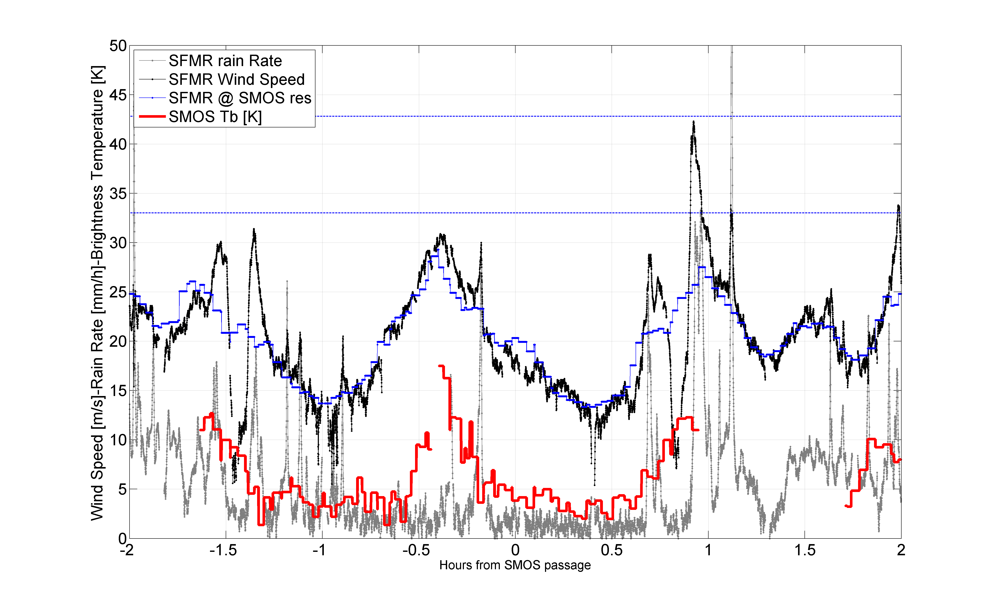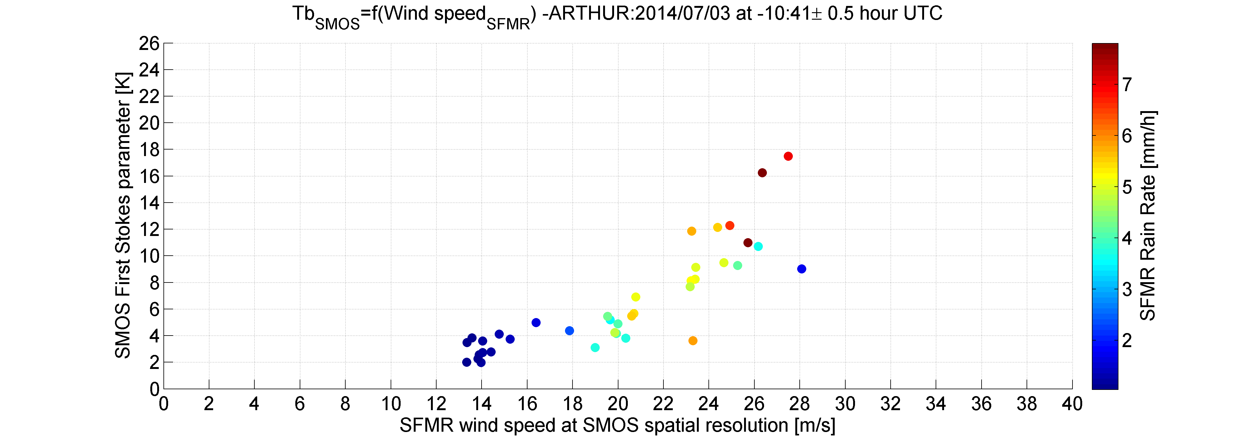

Figure: SMOS brightness temperature as function of the co-localized SFMR wind speed (x-axis in m/s) and rain rate (color in mm/h) both smoothed at SMOS spatial resolution. Only SMOS/SFMR data coincident within ±0.5 hour are shown and kept for analysis.

#### Co_localized Flight#2 over Hurricane Arthur 2014/07/03 at 23:13 UTC

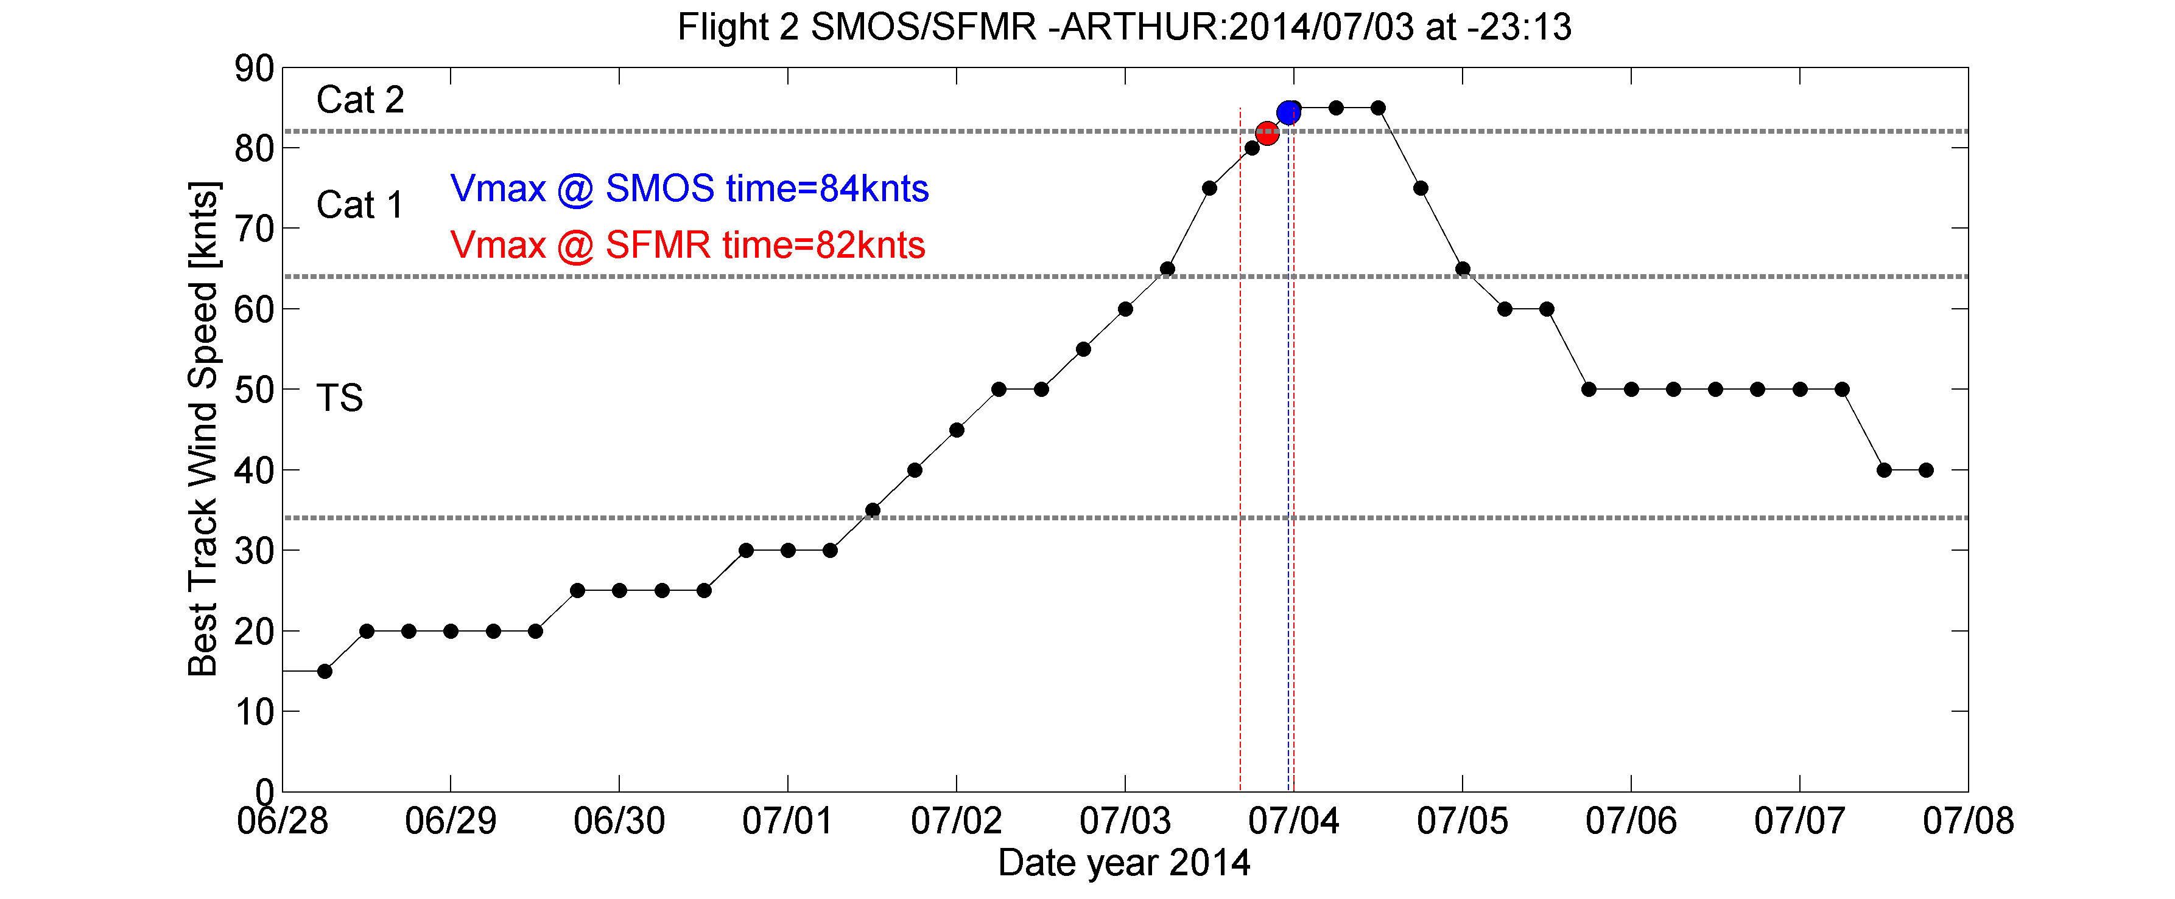

Figure: Best track maximum sustained surface wind speed (black dash dotted curve) for Hurricane Arthur, 1-5 July 2014. Red vertical lines delineates the duration of SFMR flight#2 ([NOAA 43 (1301A)](http://www.aoml.noaa.gov/hrd/Storm_pages/arthur2014/20140703H1.html)) while blue indicate time of SMOS overpass. The red and blue dots indicate the maximum wind speed at SFMR flight and SMOS pass mean acquisition times, respectively.

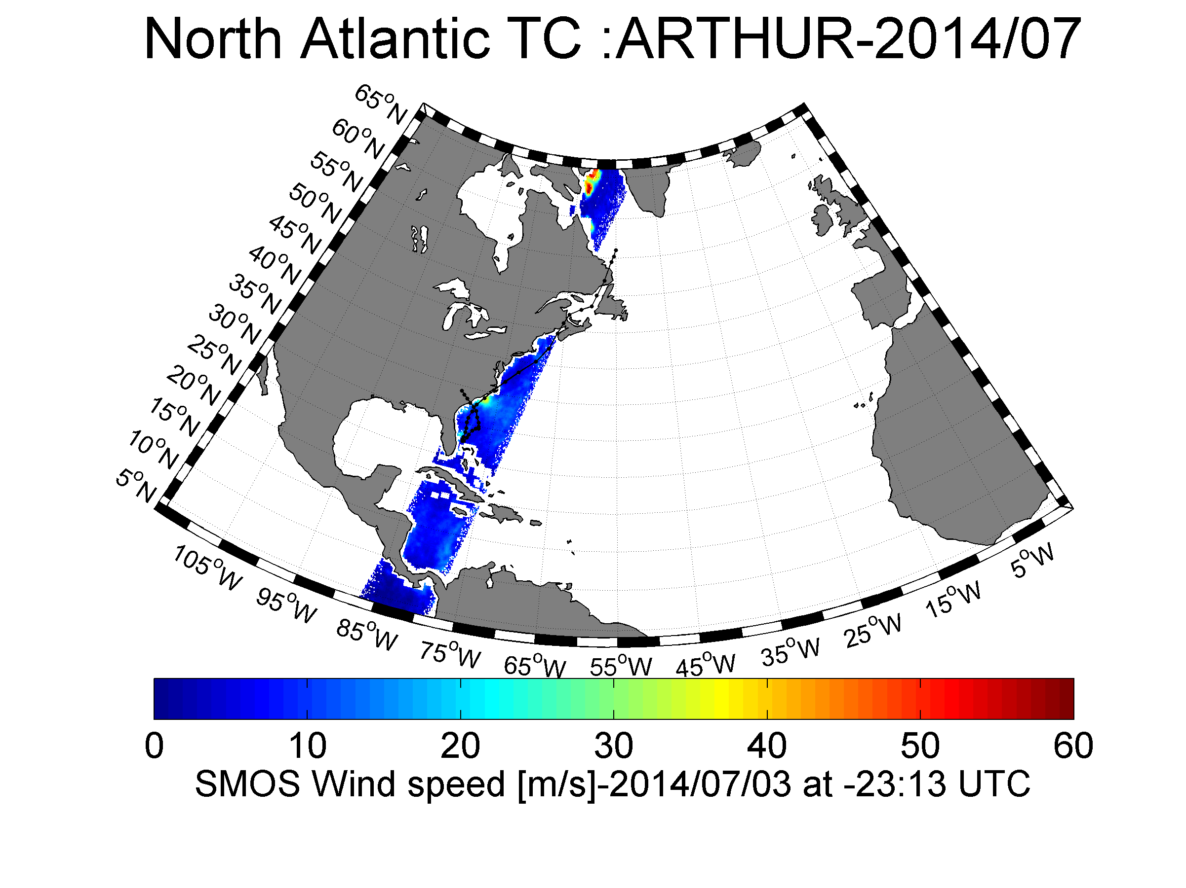

Figure: Overview of the SMOS retrieved wind speed field over Arthur on the 3 July 2014 at 23:13 UTC.

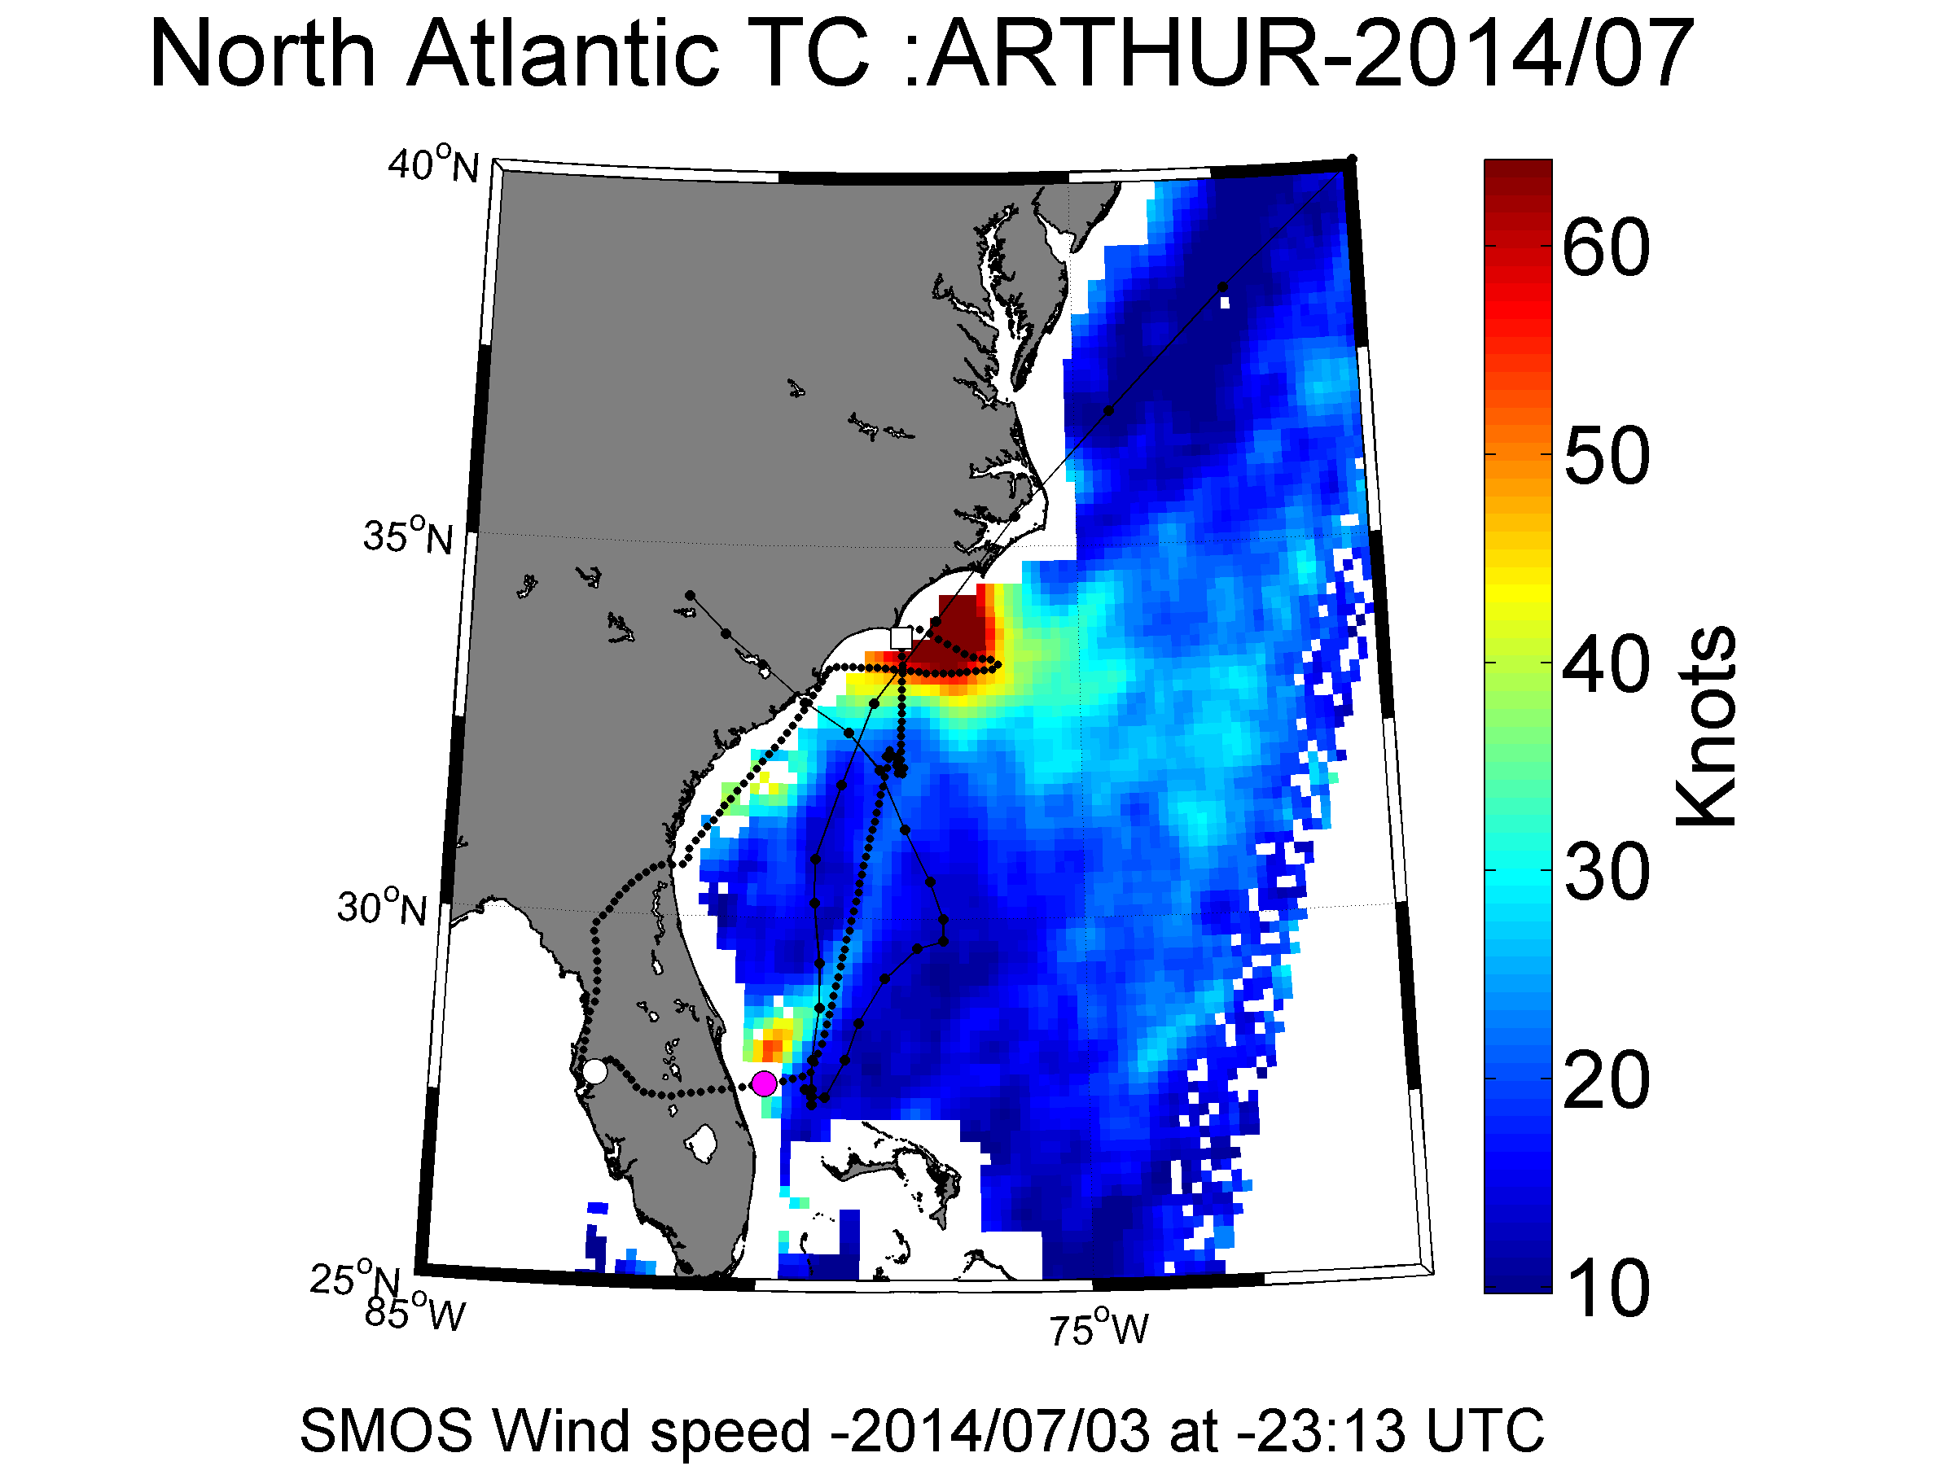

Figure: Blow up on the SMOS retrieved wind speed field over Arthur on the 3 July 2014 at 23:13 UTC. The black curve indicate the track of the SFMR flight. The pink dot indicates the location of the aircraft at SMOS acquisition time. The white dot and square indicate the location of the aircraft +2 and -2 hours apart from SMOS acquisition time, respectively.

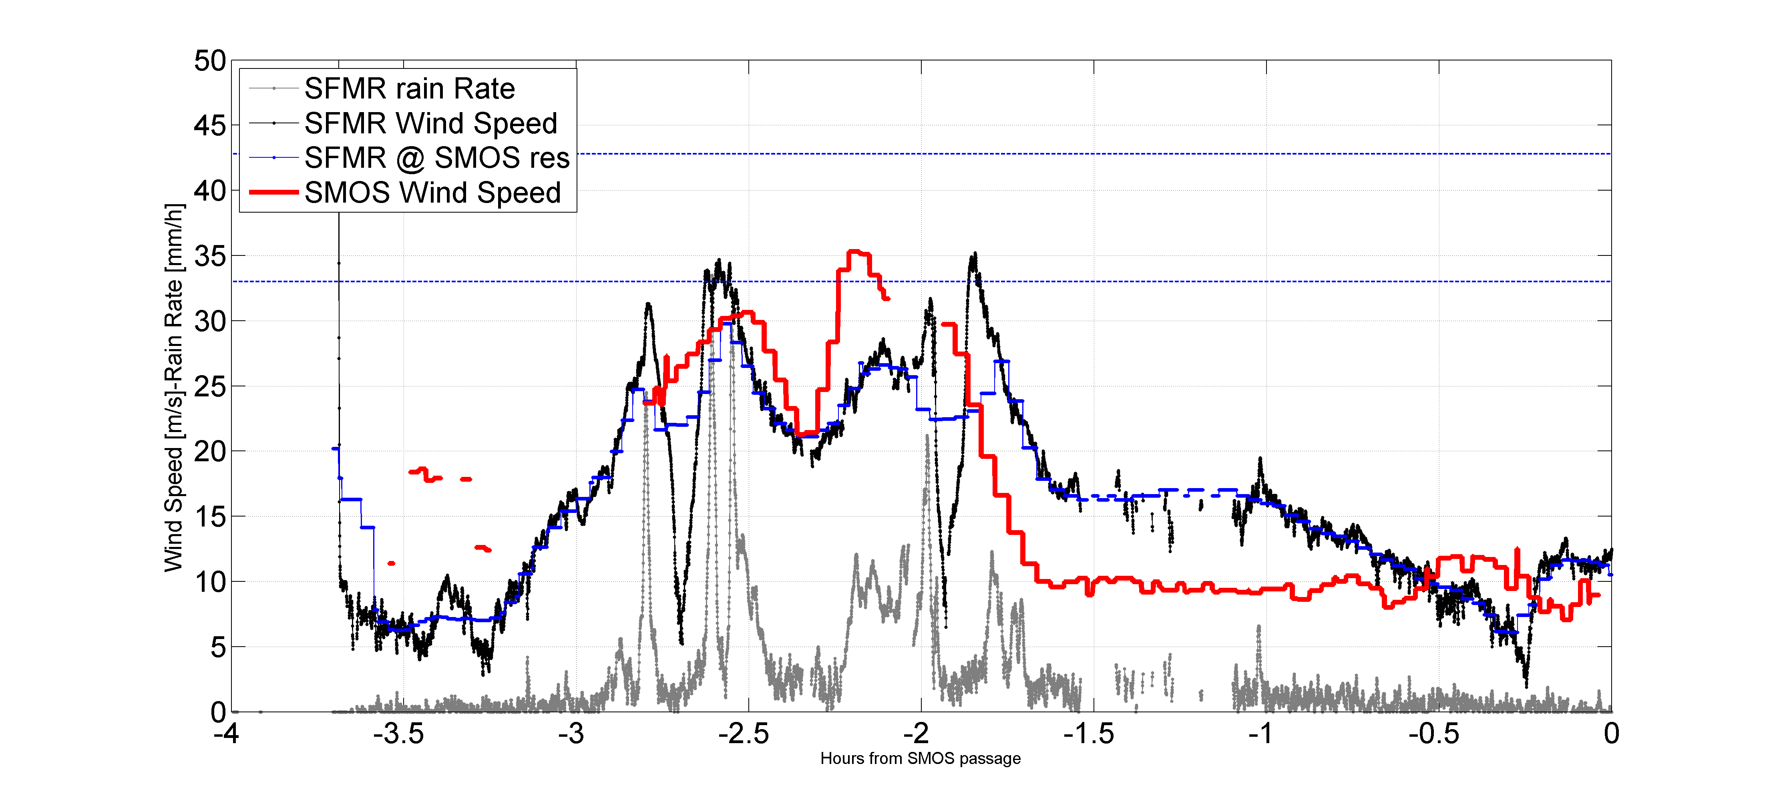

Figure: Time series of the SFMR rain rate (gray curve) and wind speed (black curve) along the aircraft track. The x-axis represent the time difference between SFMR and SMOS acquition in hours. SMFR wind speed is spatially averaged at SMOS spatial resolution (±15 km) and shown in blue. The red curve is showing SMOS wind speed retrieval interpolated along the aircraft ground track and using the first GMF version.

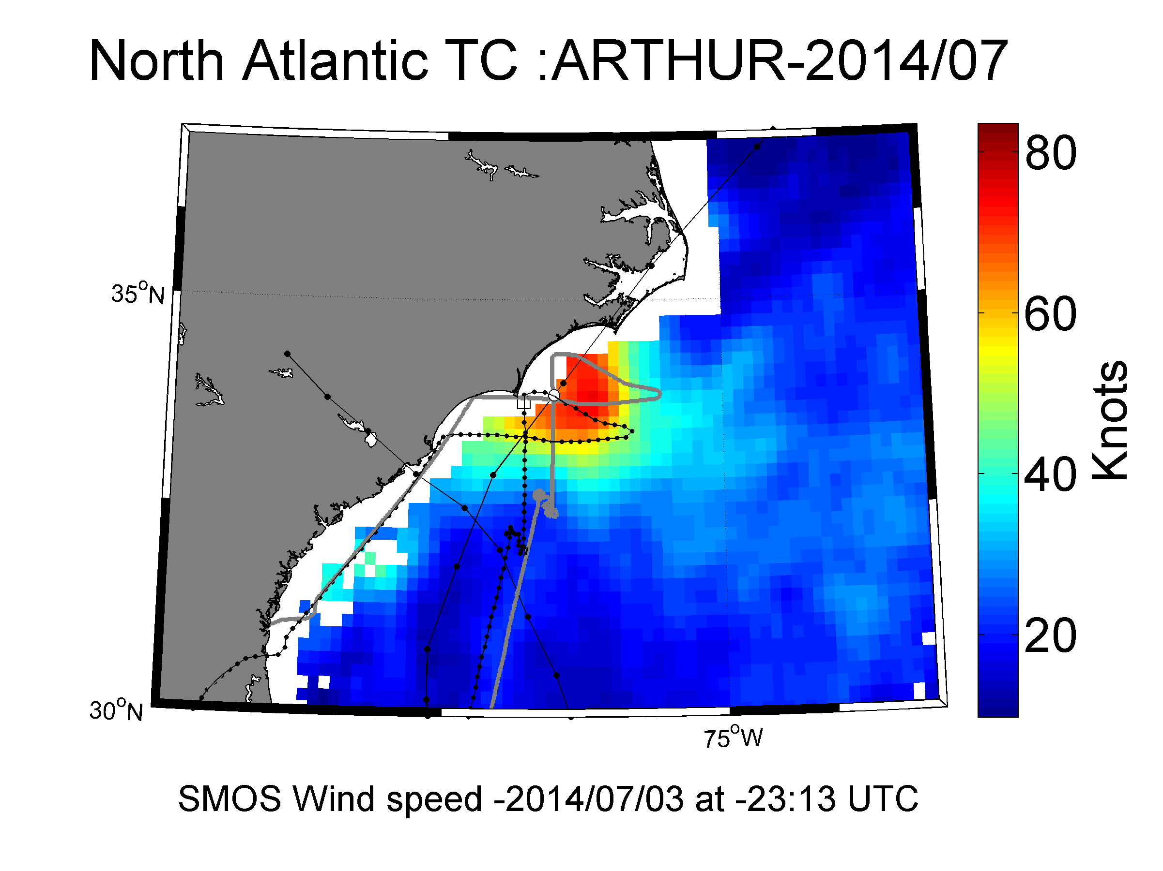

Figure: Original aircraft track (black dotted curve) superimposed on SMOS wind field. In grey: same track but translated to the position of the TC eye at SMOS acquisition time (white circle).

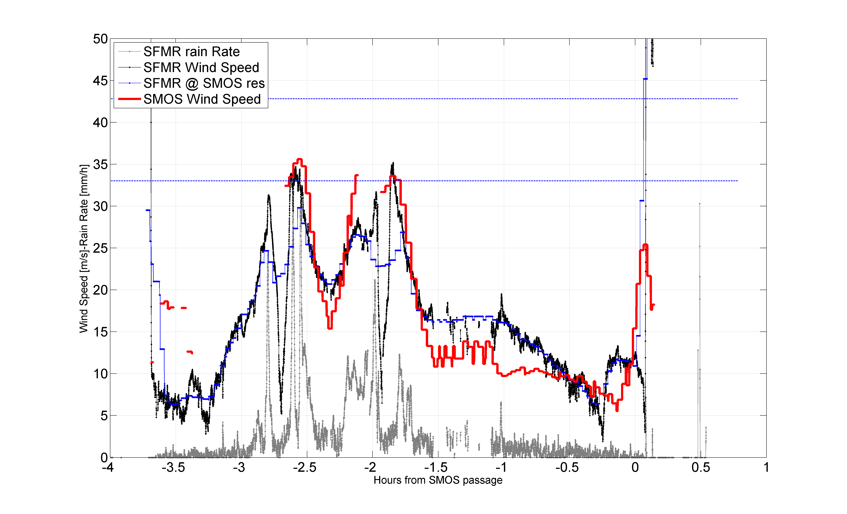

Figure: Time series of the SFMR rain rate (gray curve) and wind speed (black curve) along the aircraft track. The x-axis represent the time difference between SFMR and SMOS acquisition in hours. SMFR wind speed is spatially averaged at SMOS spatial resolution (±15 km) and shown in blue. The red curve is showing SMOS wind speed retrieval interpolated along the translated aircraft ground track and using the first GMF version.

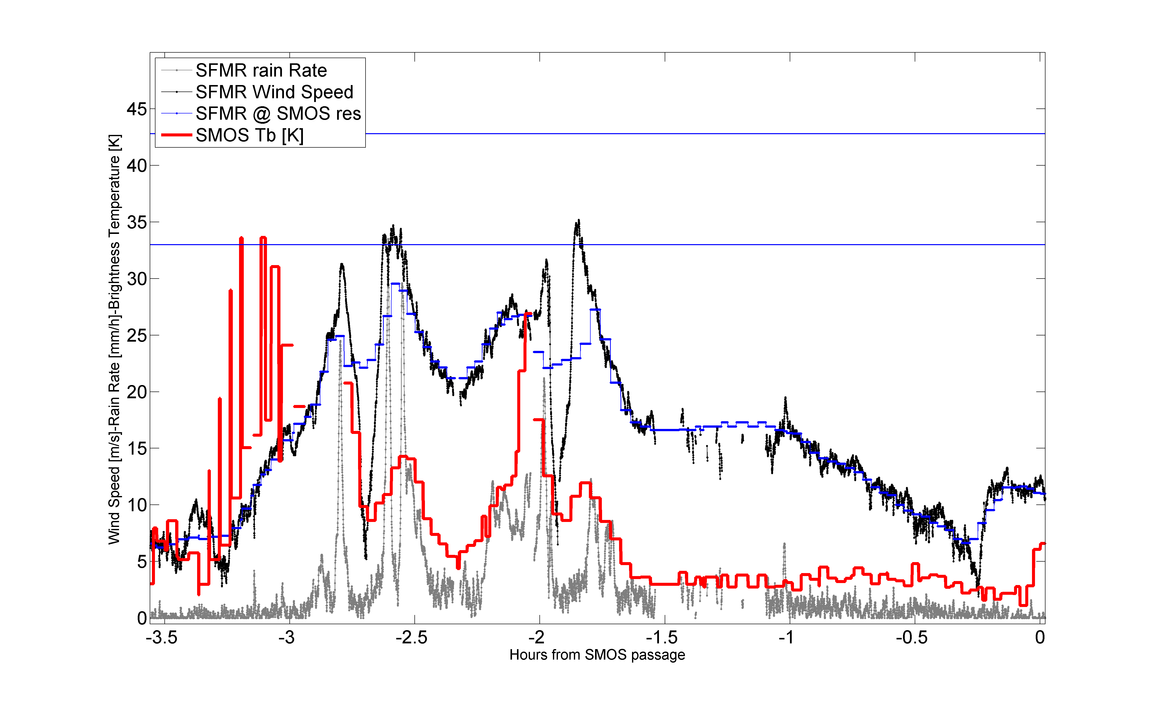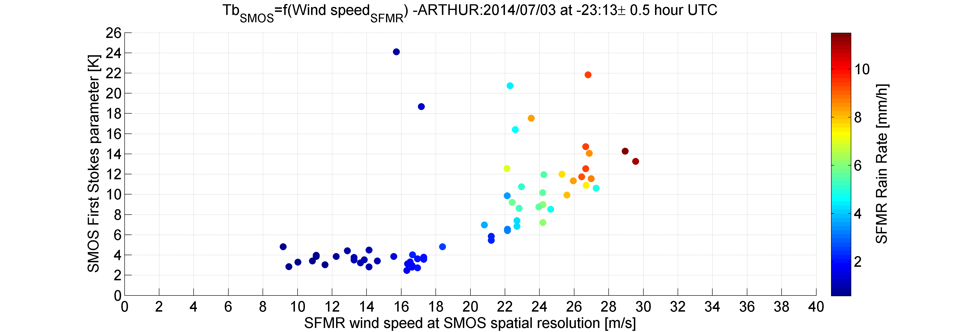

Figure: SMOS brightness temperature as function of the co-localized SFMR wind speed (x-axis in m/s) and rain rate (color in mm/h) both smoothed at SMOS spatial resolution. Only SMOS/SFMR data with time difference from -3 to 0 hour are shown and kept for analysis.

#### Co_localized Flight#3 over Hurricane Arthur 2014/07/05 at 09:23 UTC

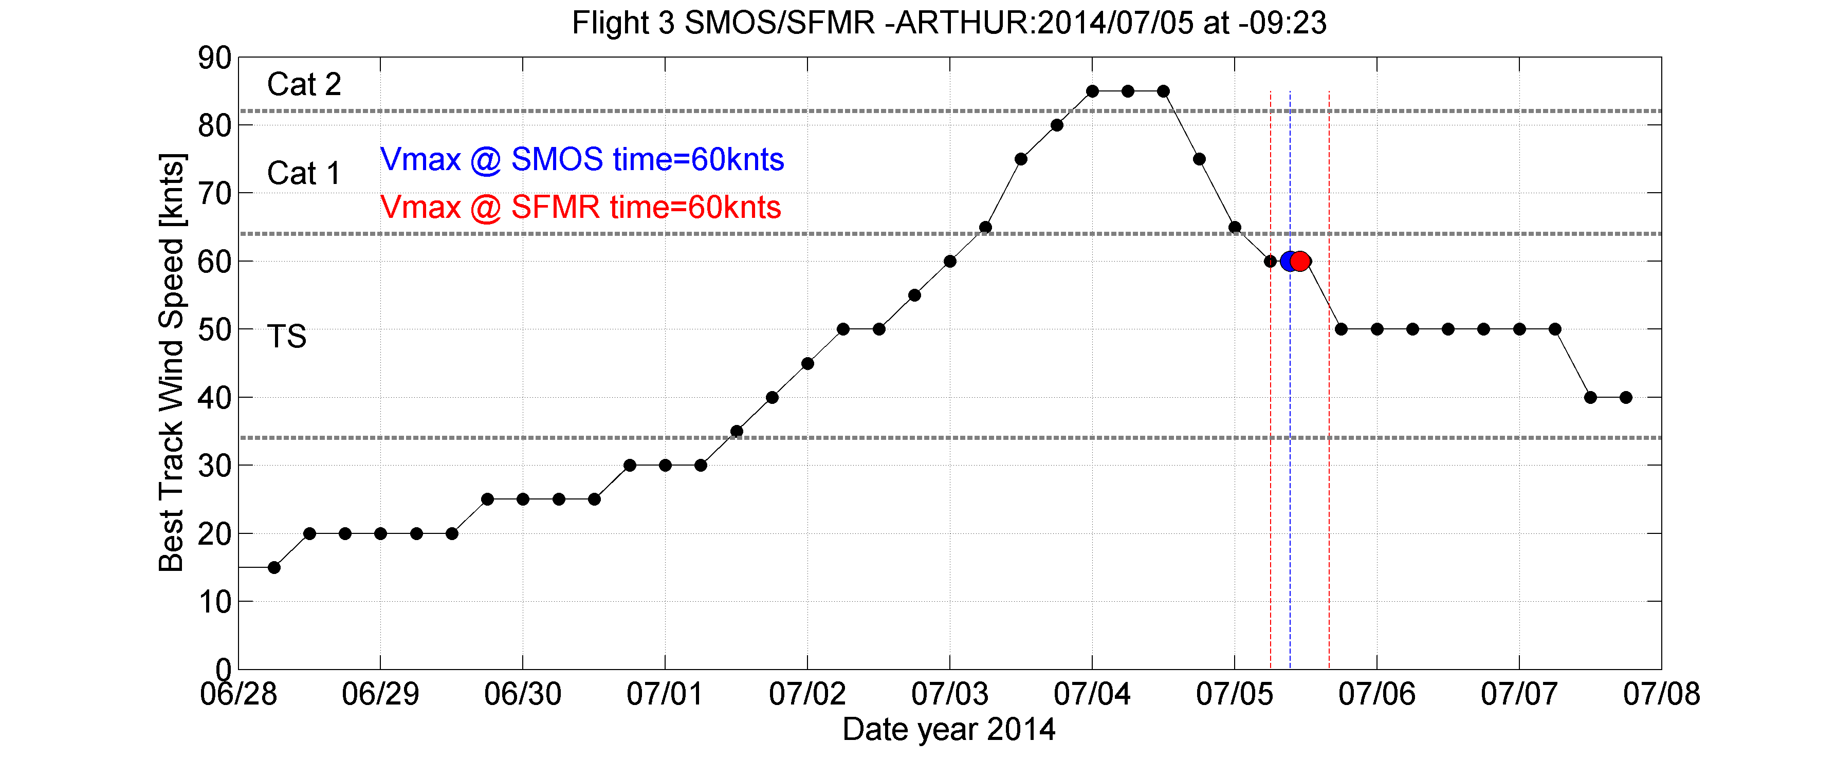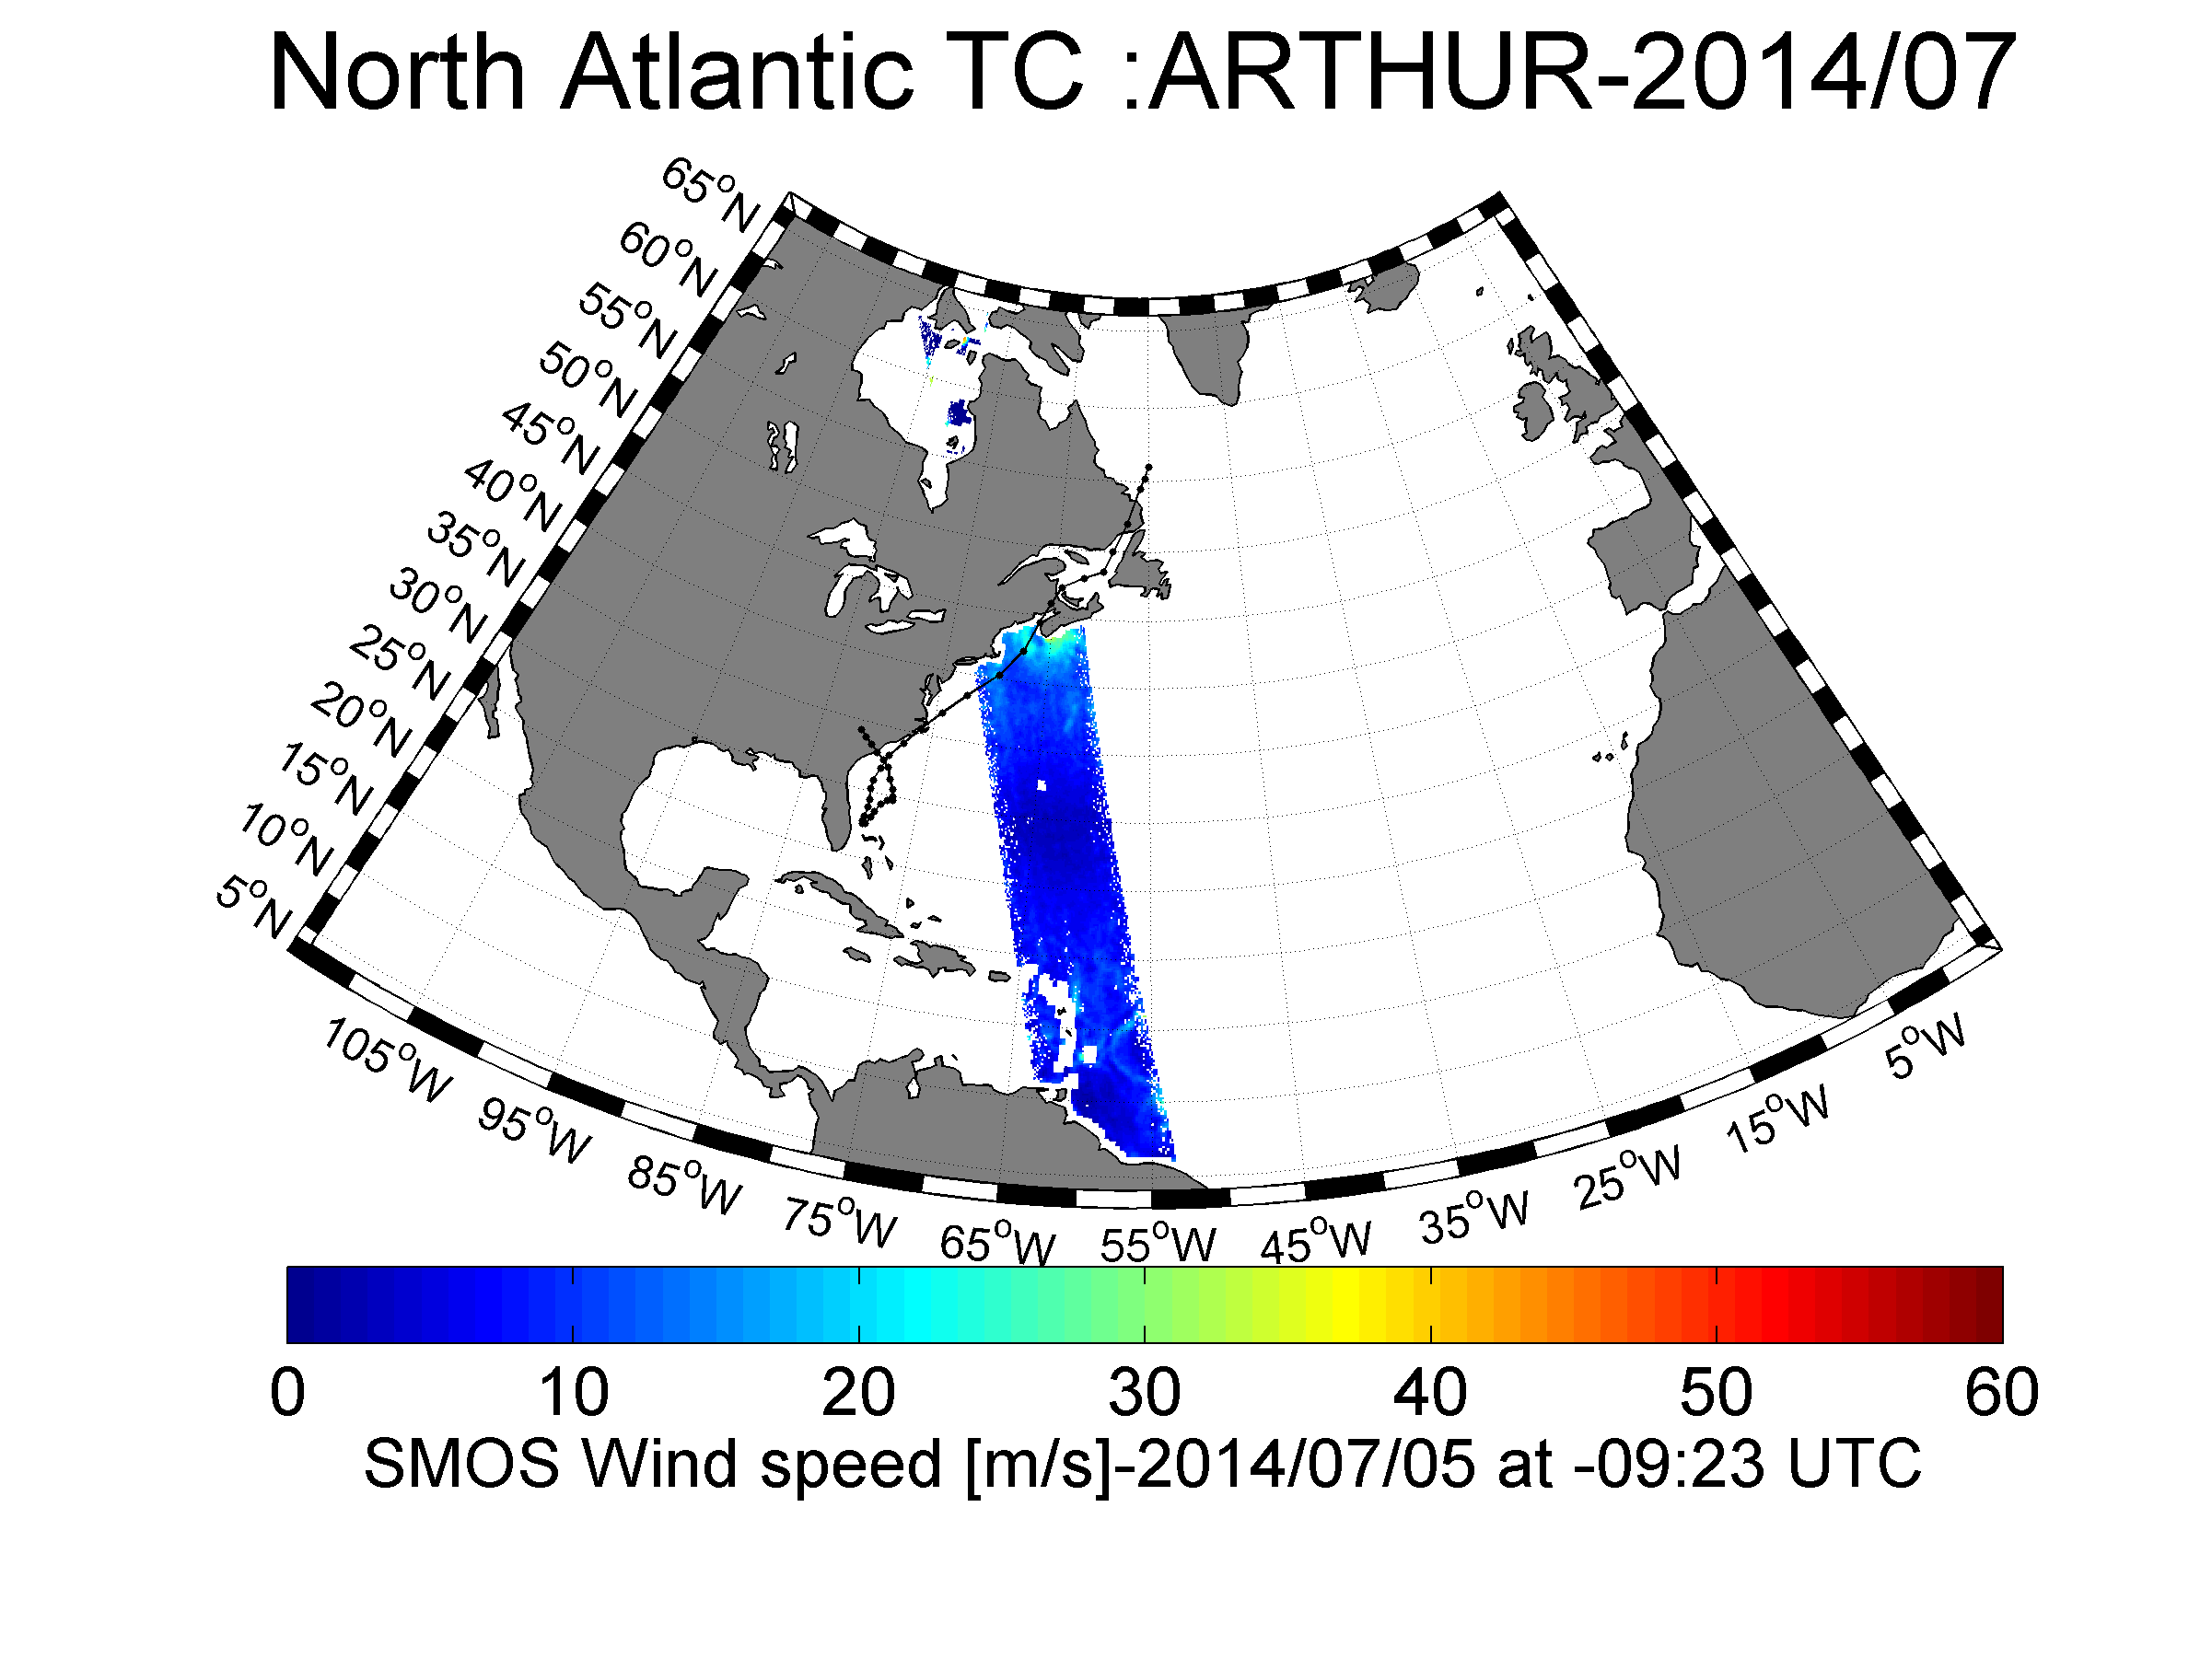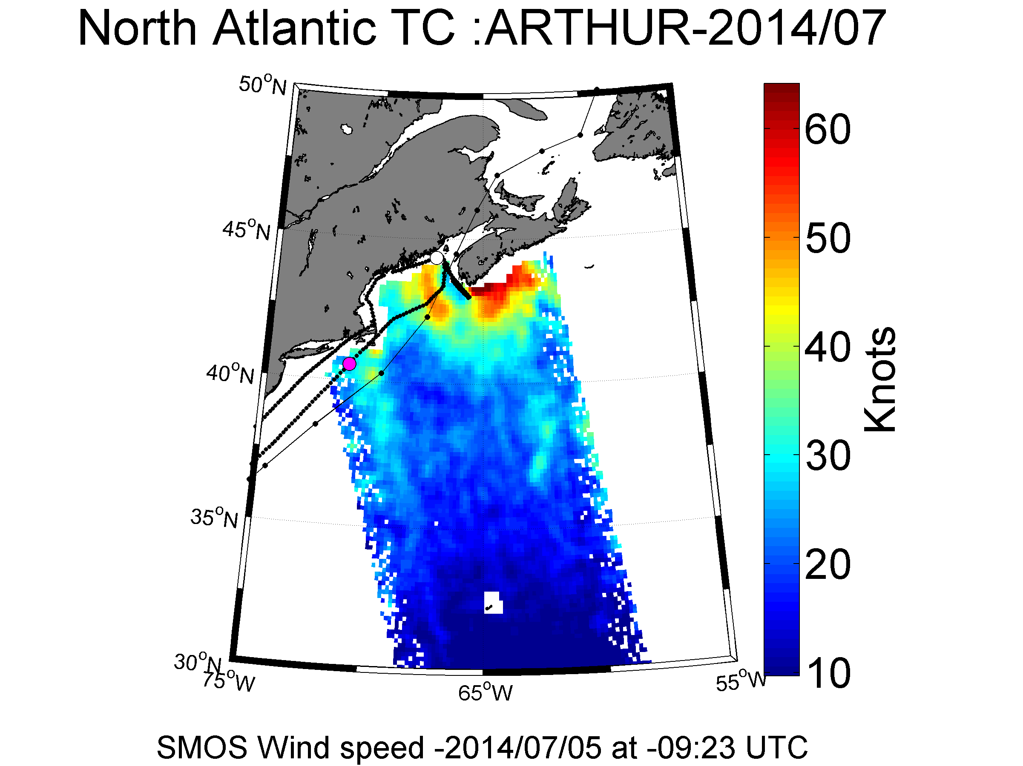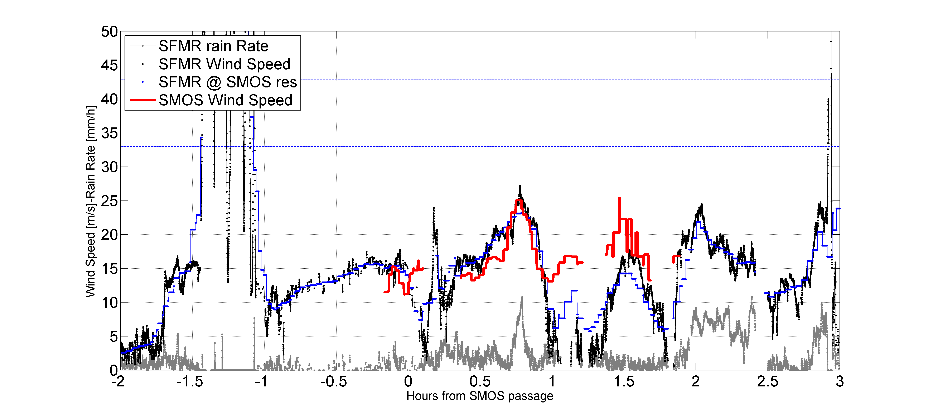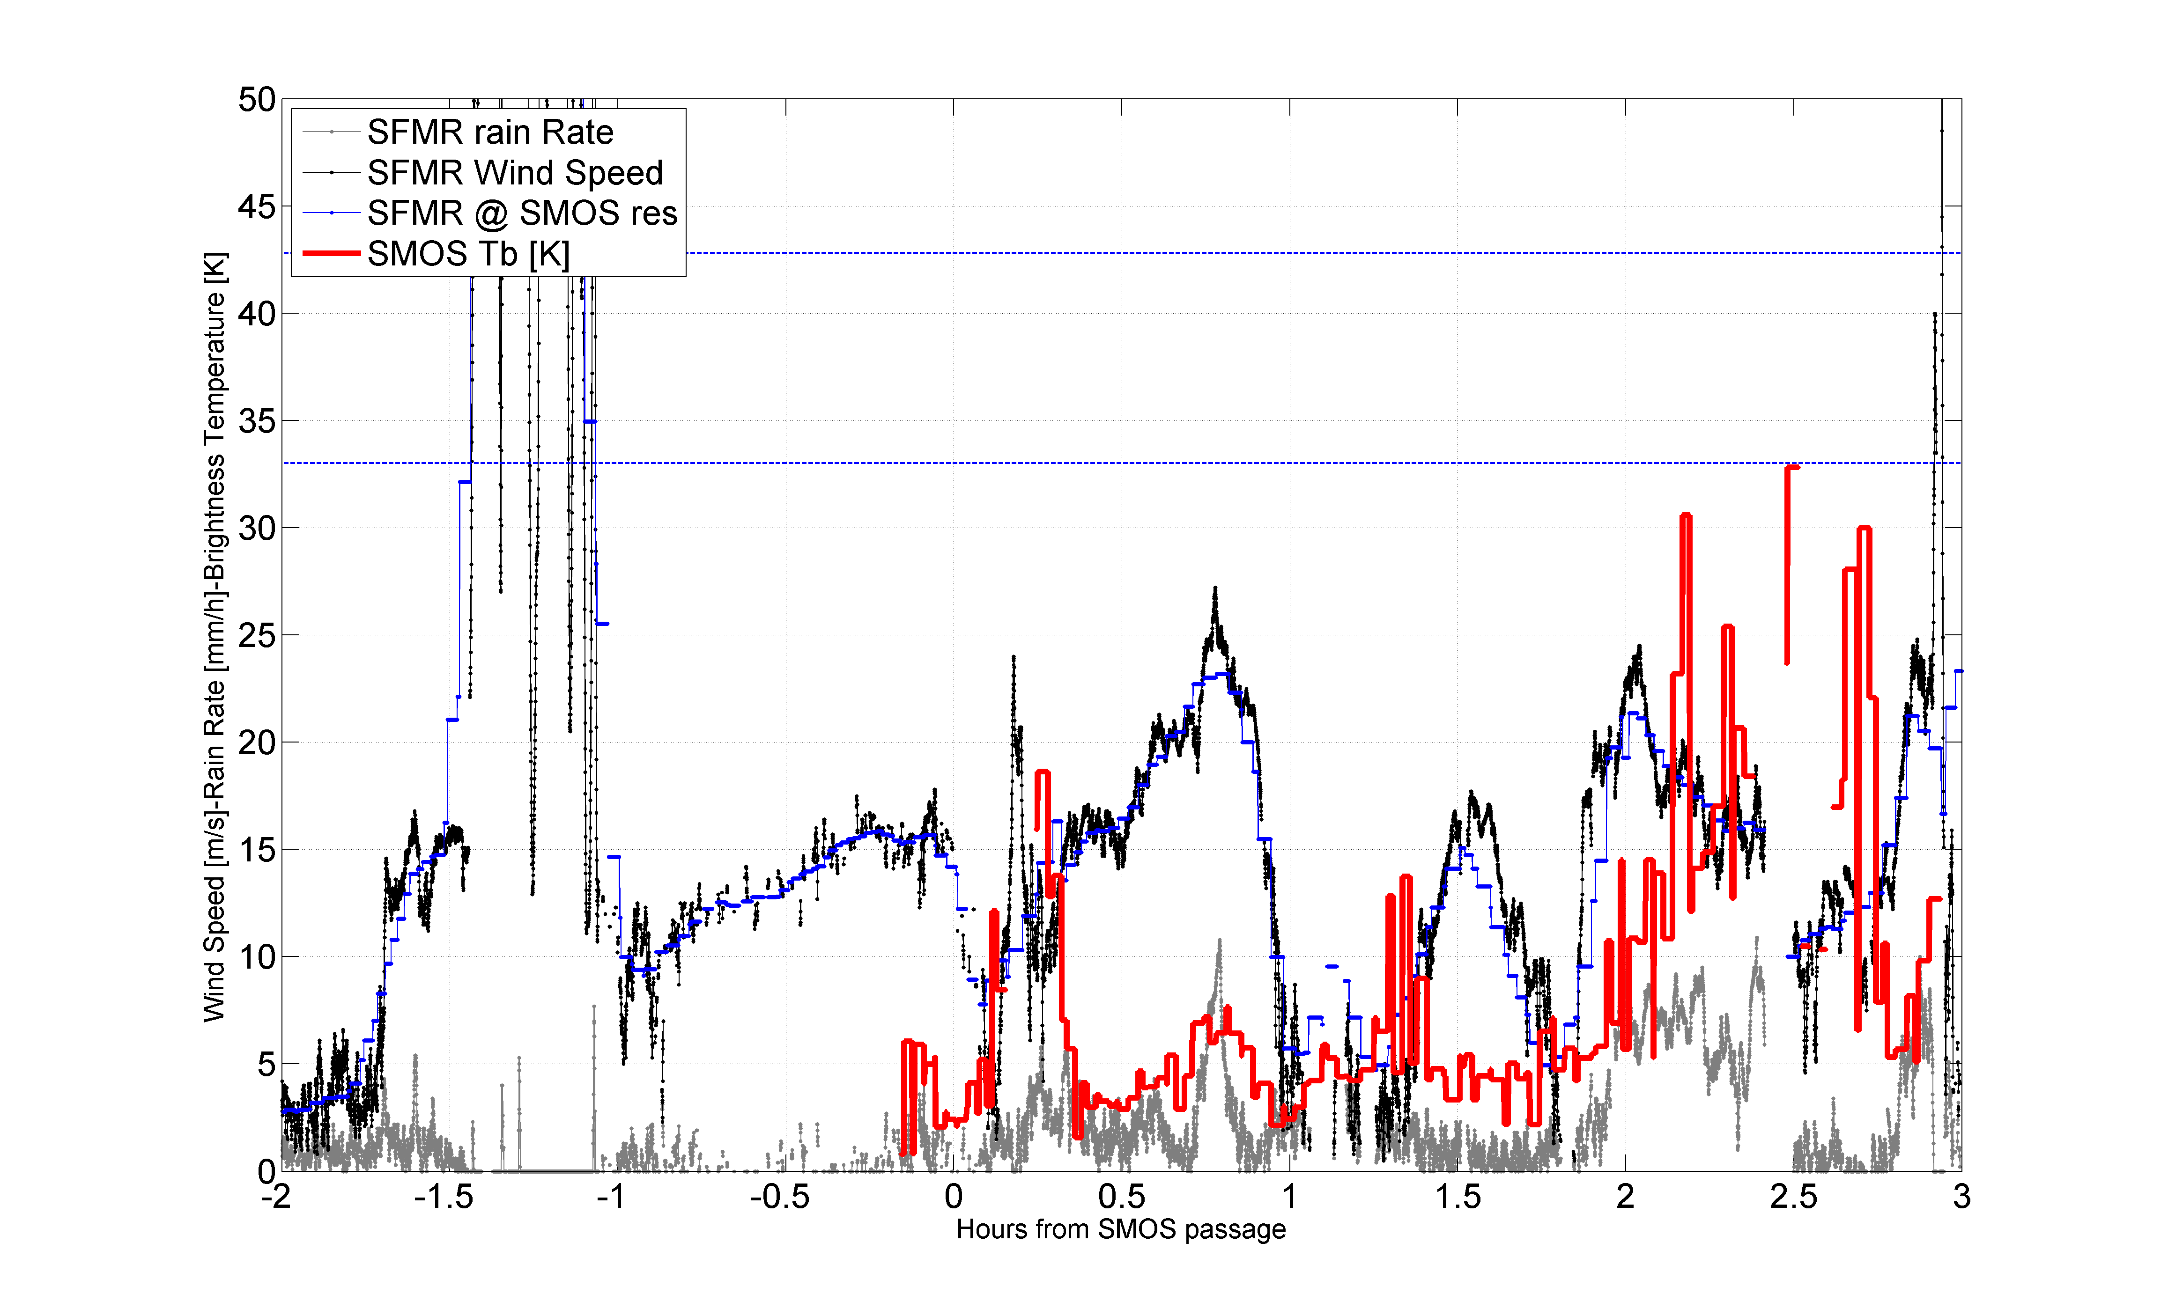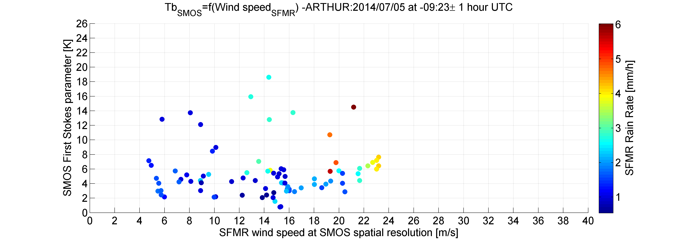

### HURRICANE BERTHA (AL032014) 1 – 6 August 2014



|  |  |  |  |  |  |  |  |  |  |
| --- | --- | --- | --- | --- | --- | --- | --- | --- | --- |
| **August 02, 2014** | | | | | | | | | |
| [NOAA 42 (0503A)](http://www.aoml.noaa.gov/hrd/Storm_pages/bertha2014/20140802H1.html) | 17:08-01:22 Z | TDR | [SFMR](ftp://ftp.aoml.noaa.gov/hrd/pub/data/sfmr/2014/bertha/NOAA_SFMR20140802H1.nc) |  |  |  |  |  |  |
| **August 03, 2014** | | | | | | | | | |
| [NOAA 42 (0803A)](http://www.aoml.noaa.gov/hrd/Storm_pages/bertha2014/20140803H1.html) | 17:46-02:29 Z | TDR | [SFMR](ftp://ftp.aoml.noaa.gov/hrd/pub/data/sfmr/2014/bertha/NOAA_SFMR20140803H1.nc) |  |  |  |  |  | SMOS 2014/08/03 at 23:06 UTC |
| **August 04, 2014** | | | | | | | | | |
| [NOAA 43 (1003A)](http://www.aoml.noaa.gov/hrd/Storm_pages/bertha2014/20140804I1.html) | 06:03-14:11 Z | TDR | [SFMR](ftp://ftp.aoml.noaa.gov/hrd/pub/data/sfmr/2014/bertha/NOAA_SFMR20140804I1.nc) |  |  |  |  |  | SMOS 2014/08/04 at 09:55 UTC |
| [NOAA 42 (1203A)](http://www.aoml.noaa.gov/hrd/Storm_pages/bertha2014/20140804H1.html) | 18:16-02:11 Z | TDR | [SFMR](ftp://ftp.aoml.noaa.gov/hrd/pub/data/sfmr/2014/bertha/NOAA_SFMR20140804H1.nc) |  |  |  |  |  |  |
| **August 05, 2014** | | | | | | | | | |
| [NOAA 43 (WB03A)](http://www.aoml.noaa.gov/hrd/Storm_pages/bertha2014/20140805I1.html) | 03:57-14:10 Z | TDR | [SFMR](ftp://ftp.aoml.noaa.gov/hrd/pub/data/sfmr/2014/bertha/NOAA_SFMR20140805I1.nc) |  |  |  |  |  |  |

#### Co_localized Flight#1 over Hurricane Bertha 2014/08/03 at 23:06 UTC

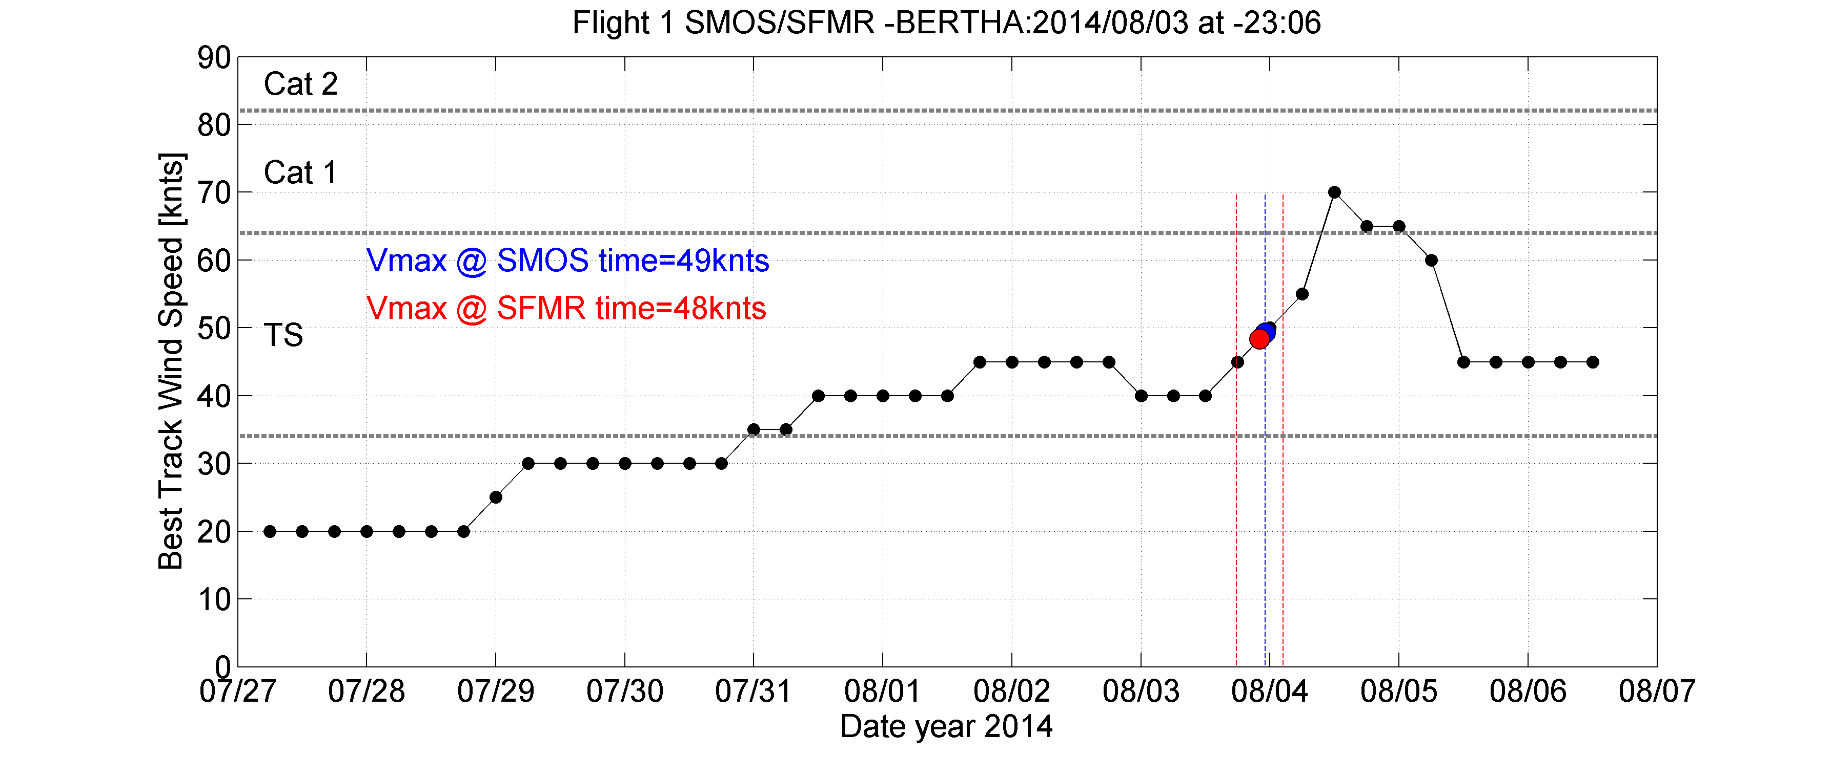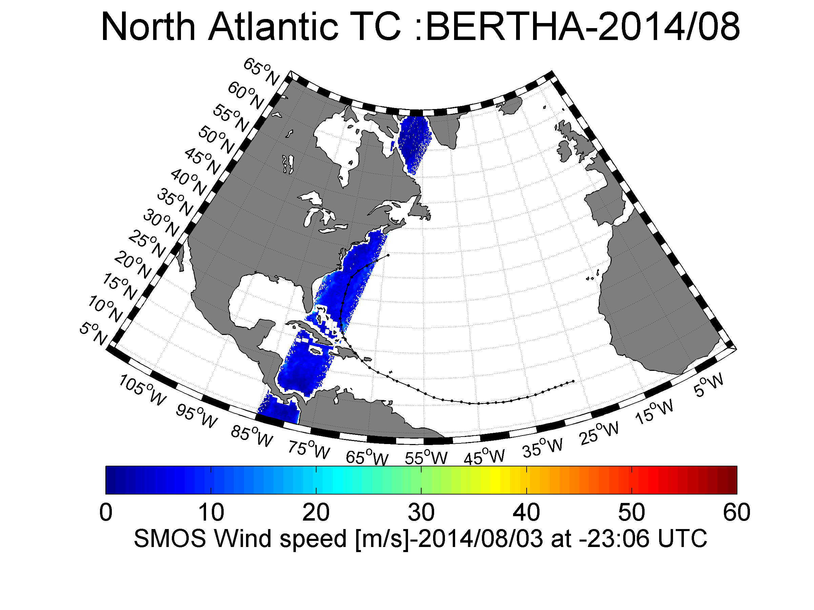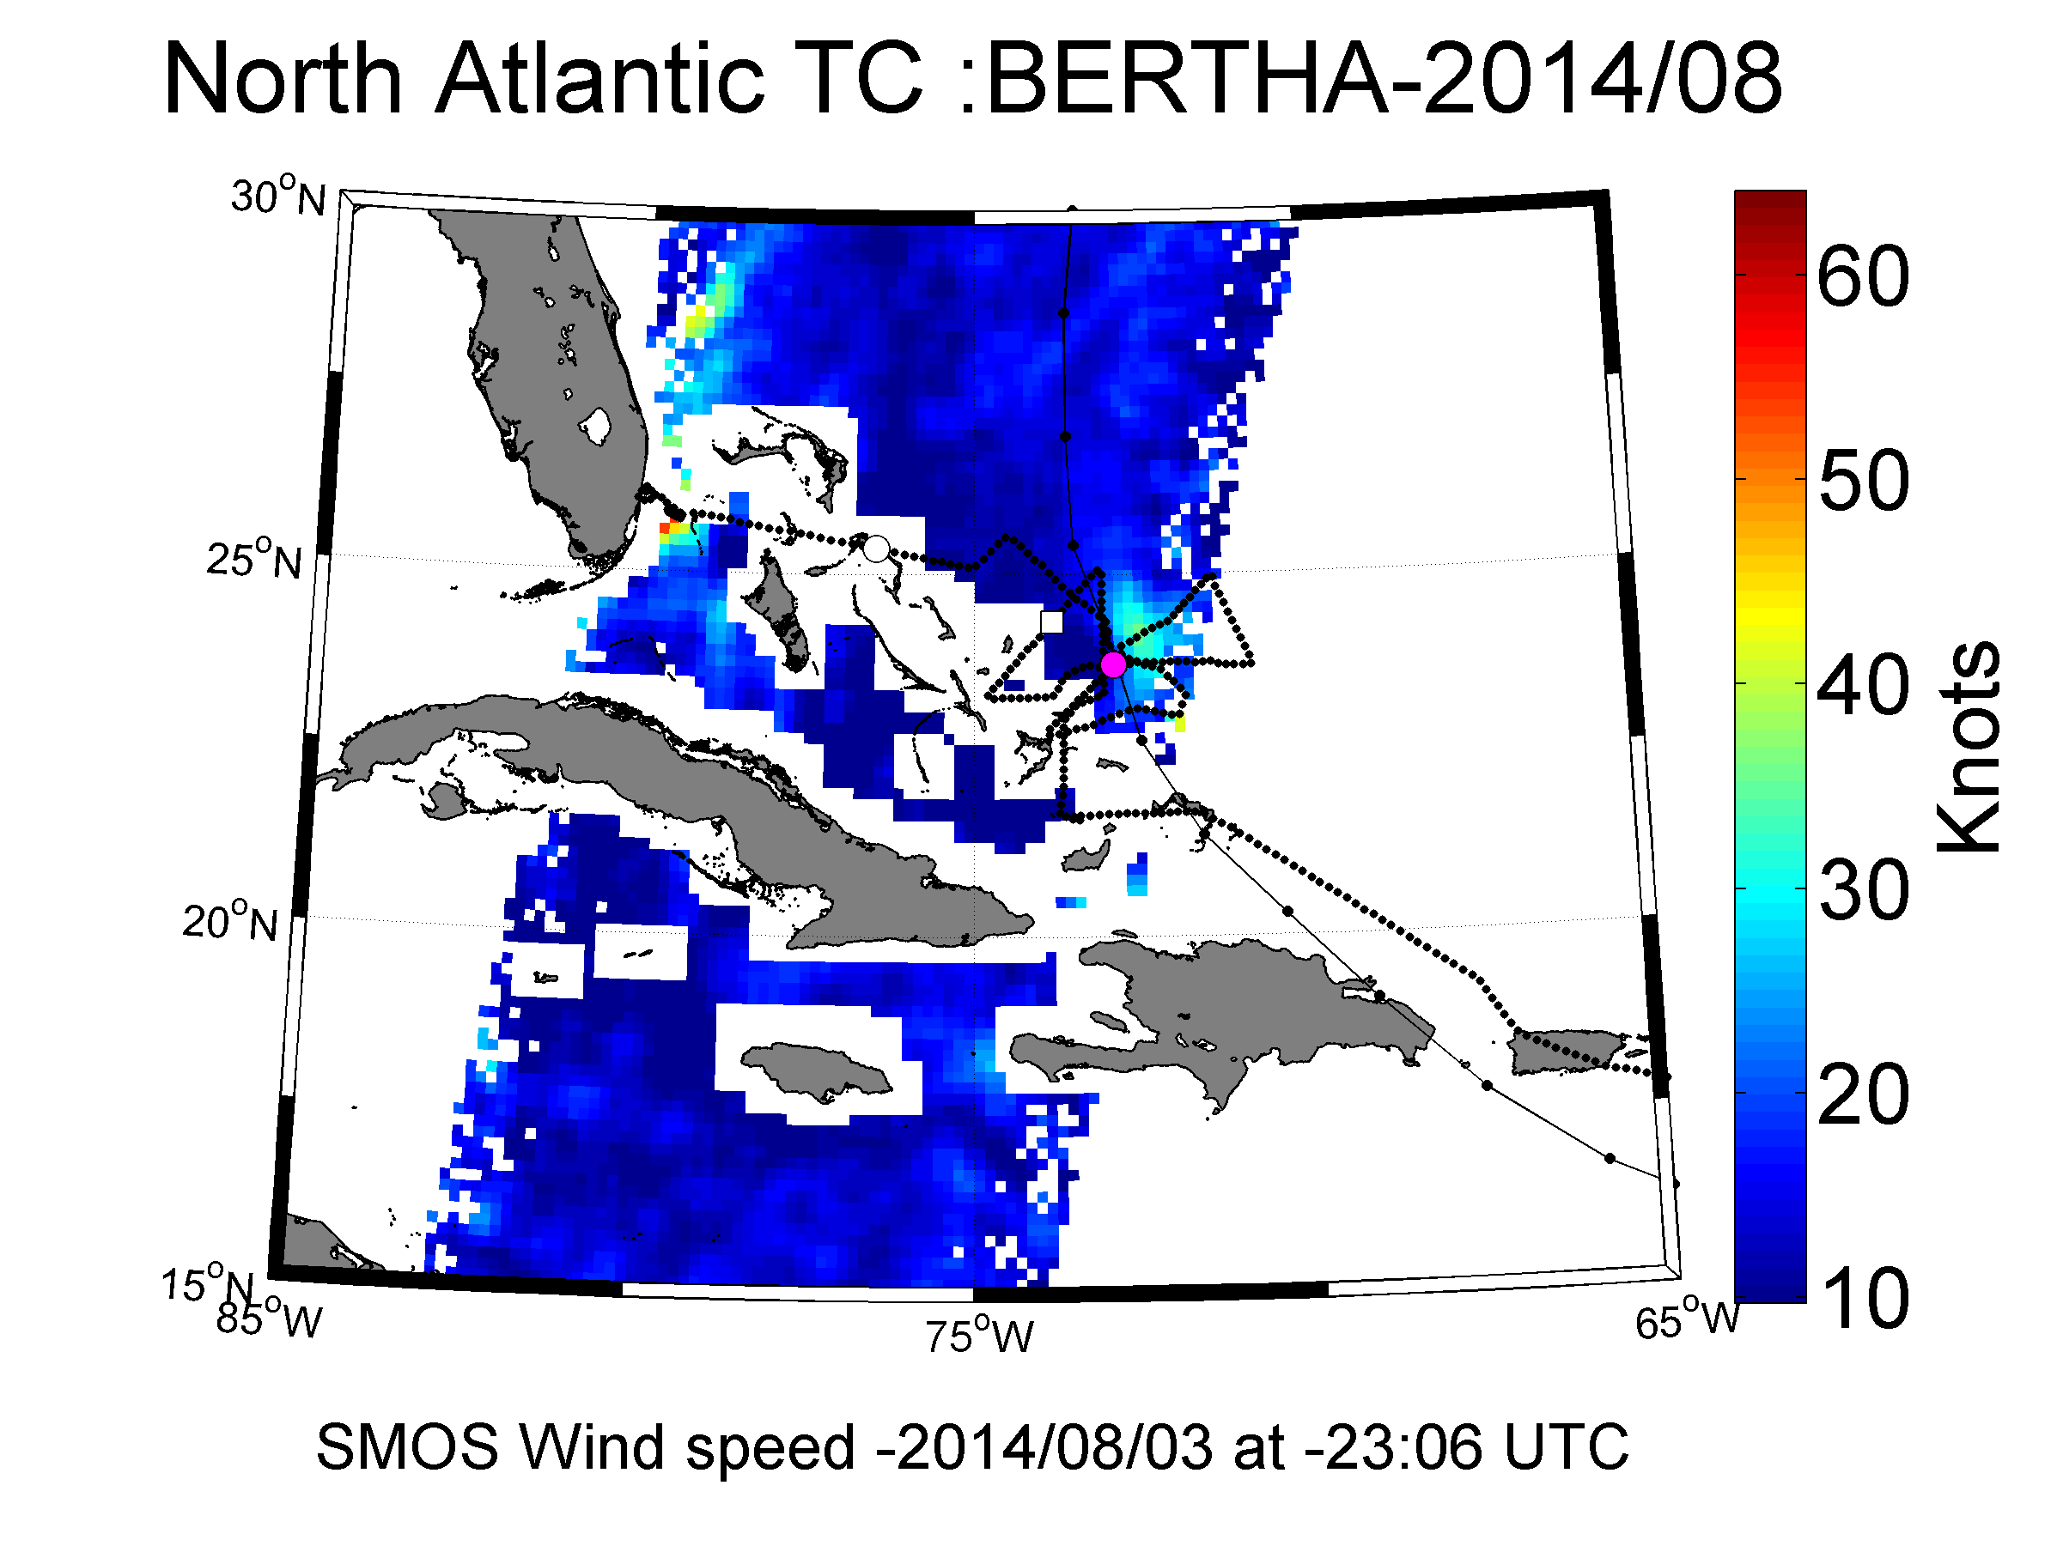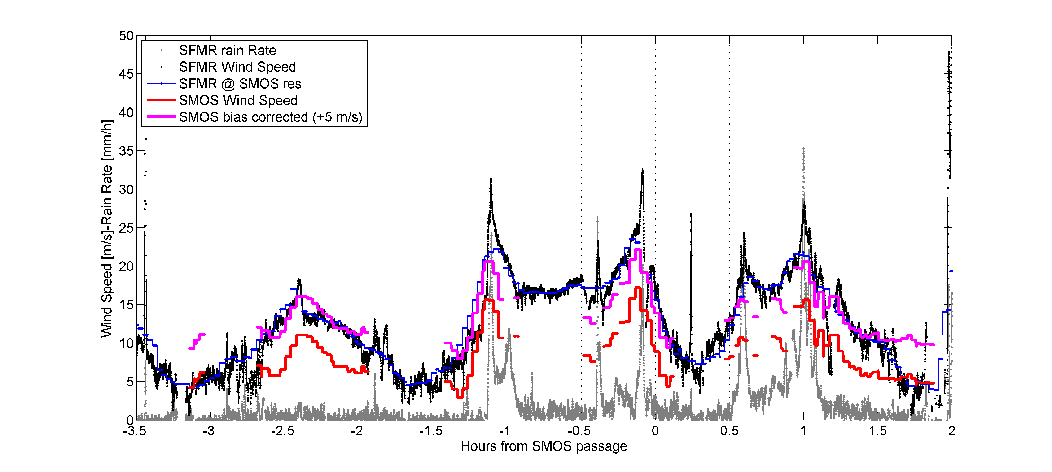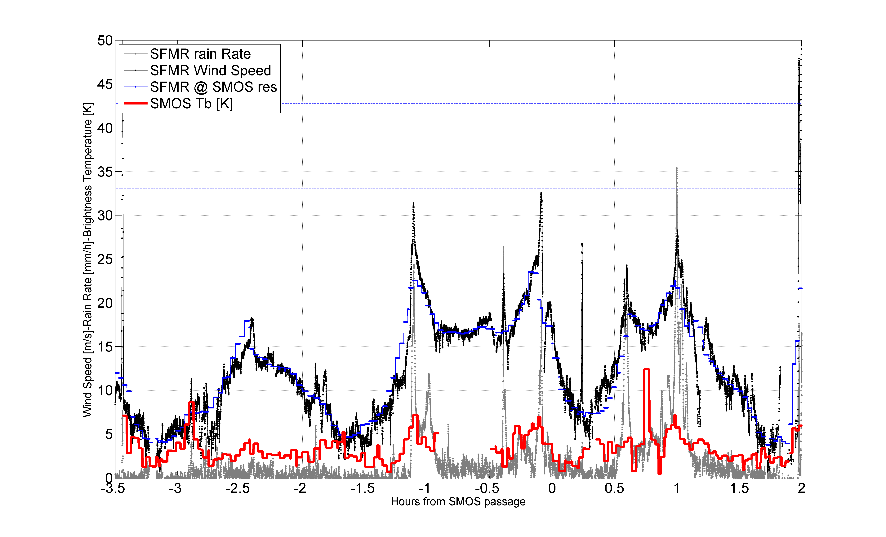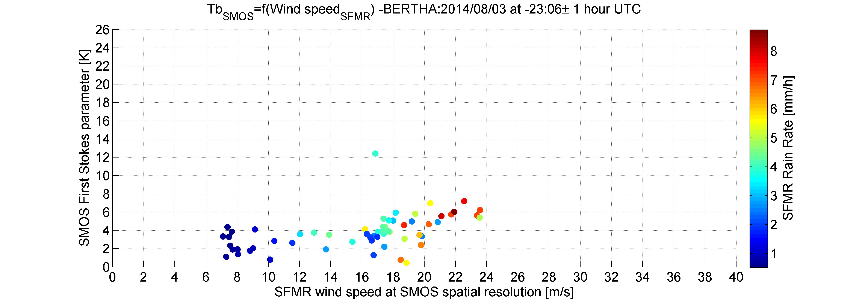

#### Co_localized Flight#2 over Hurricane Bertha 2014/08/04 at 09:55 UTC

